The Property of _____________________________

[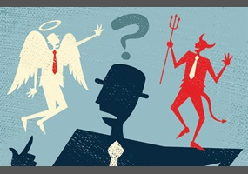](http://www.google.co.uk/url?sa=i&rct=j&q=&esrc=s&source=images&cd=&cad=rja&uact=8&ved=0ahUKEwi9yfvNnNfVAhWILhoKHUwCB-4QjRwIBw&url=http://www.debate.org/opinions/is-religion-required-to-have-a-set-of-correct-morals-and-values-ethics&psig=AFQjCNFc9Zy2iPwuRQaLTu1DYoa4UsnmEQ&ust=1502817173034997)Edexcel PAPER 1: RELIGION & ETHICS through CHRISTIANITY

REVISION BOOKLET

**[](http://images.google.co.uk/imgres?imgurl=http://www.prestwich.bury.sch.uk/www/images/exam.gif&imgrefurl=http://www.prestwich.bury.sch.uk/examtime.html&h=215&w=188&sz=14&hl=en&start=50&tbnid=RNMYCEnw0iHECM:&tbnh=106&tbnw=93&prev=/images?q=exam+revision&start=40&gbv=2&ndsp=20&svnum=10&hl=en&sa=N)[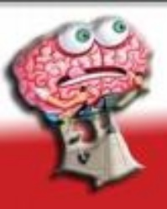](http://images.google.co.uk/imgres?imgurl=http://www.u2learn.com/images/bottom_bar/brain.jpg&imgrefurl=http://www.u2learn.com/gcse-biology-links.html&h=186&w=149&sz=7&hl=en&start=9&tbnid=LmGBYME3EC59GM:&tbnh=102&tbnw=82&prev=/images?q=exam+revision&gbv=2&svnum=10&hl=en&sa=G)**REMEMBER…

This exam lasts **1 hour and 45 minutes**, and is worth 50% of your overall mark. You will have to **answer 4 questions** - broken down into 4 parts: a), b), c) and d) - aim to spend roughly **25 minutes** on each section.

**It’s crucial you use this revsion booklet alongside your exercise books.**

The Basics —Read the Questions

1) Read the questions carefully. Remember to answer all parts of the questions.

2) Be aware of how much time you’re using. Leave plenty of time for the long‑answer questions. The more marks a question’s worth, the longer you should be spending on it — for these exams, allow around 1 minute per mark. Try to leave yourself 5 minutes at the end to check your work.

3) Some questions will have extra marks available for Spelling, Punctuation and Grammar (SPaG) — 6 marks in total for each paper. The exam paper will tell you which questions offer SPaG marks — so make your writing for these the best it can be.

4) Don’t use any fancy colours — write only in black ink.

There are Two Types of Part (a) Questions

* Part (a) questions are worth 3 marks.

* They’re straightforward - 3 short points will earn you full marks. You’ll be asked to either ‘State’ or ‘Outline’.

* ‘STATE’ QUESTIONS: These will only ask you to write down three points and you don’t need to write in a full sentence.

***E.g. a) State three religious traditions, other than Christianity, in Great Britain. (3)***

*Judaism, Islam and Buddhism.*

*\* ‘OUTLINE’ QUESTIONS: These questions could ask you about different aspects, e.g. religious beliefs on a topic, teachings, or ways that believers do something. Keep your answers short - 3 points for 3 marks.*

**E.g. a) Outline three Christian beliefs about marriage.**

Three Christian beliefs about marriage are that it is the proper place to have sex, it is a demonstration of love and commitment, and it is the place to have and raise Christian children.

Don’t be tempted to write lots - this answer would be enough to get you 3 marks.

Part (b) Questions will usually ask you to ‘Explain two …’

* Part (b) questions are worth 4 marks.

* You need to give two reasons; you will not get marks for giving more than two reasons.

* You need to demonstrate a higher level of understanding by giving a reason and then by developing it.

* Development must address both the question set and the reason already given; they must link clearly.

* The best forms of development are quotations, examples and evidence which support the reason.

* To get full marks, you need to: give a reason and then develop it, then give a second different reason and develop it in a way that is also different from the first reason.

**E.g. Explain two reasons why the Lord’s Prayer is important for Christians.**

The Lord’s Prayer is important for Christians because Jesus gave it to his disciples as an example of how they should pray. Secondly, it reminds Christians that God’s Kingdom will eventually come to this earth which gives life meaning and purpose.

Comparison of Christianity and Islam

* You should compare and contrast two areas of belief and practice within Christianity with Islam:

**● Beliefs about the afterlife and their significance (Section 1)**

**● The practice and significance of worship (Section 3)**

* You will be expected to study Christianity within the context of the wider British society.

**E.g. Describe two differences in forms of worship between Islam and the main religious tradition of Great Britain.**

You are required to recognise that Christianity is the main religious tradition of Great Britain.

Muslims must wash before worship, but Christians are not commanded to prepare for worship by washing.

Secondly, Muslims have prescribed times for worship, yet Christians can choose their own times for communal worship.

Part (c) Question Will ask you to ‘Explain two…’

* Part (c) questions are worth 5 marks.

* They will ask you to explain two aspects, such as beliefs, teachings, ways that believers respond, or reasons why something is important.

* You need to give two points and develop them, but for full marks you must refer to a source of wisdom and authority (sacred text or religious teaching). This could be quotations, or by paraphrasing - explaining what’s said in your own words. You’ll need to say which text or teaching the information comes from.

* There’s only one mark available for including a source, so one quote or reference will do.

**E.g. Explain two ways Christians respond to the problem of evil and suffering. In your answer, you must refer to a source of wisdom and authority.**

Christians will teach that God knows why people suffer and he uses suffering to show his love and faithfulness to people as he promises to comfort his followers. Christians also respond in a practical way to the suffering of others and try to relieve suffering in whichever way is needed. This is in response to the Parable of the Sheep and Goats where Jesus says ‘Truly I tell you, whatever you did for one of the least of these brothers and sisters of mine, you did for me’ (Matthew 25:31-46).

Part (d) Questions will ask you to ‘evaluate…’

* You’ll need to write a longer answer for the part (d) question. It’s worth 12 or 15 marks, depending on whether it tests SPaG (see below).

* You’ll be given a statement and a list of bullet points — these tell you what to put in your answer.

* You need to give arguments for and against the statement, so read it carefully, then make a rough list of all the views on each side that you can think of.

* Plan out your answer before you start writing — it needs to be clear and organised for the examiner.

**E.g. ‘Animal experimentation should be al****lowed if it benefits humanity.’ Evaluate this statement.**

**Give arguments for and against the statement.**

**You must include:**

**• examples from Christian teachings**

**• different Christian opinions**

**• appropriate ethical arguments**

**• a conclusion.**

Some Christians share this point of view. They believe that animal testing is acceptable if it is for valid reasons, such as producing life-saving medicines. But many Christians see themselves as stewards of the Earth, and believe they must care for animals — the Bible says that righteous people look after their animals. They think that the animals must be treated humanely, and no unnecessary pain caused. This view is reflected in the Catechism of the Catholic Church. It says that animal testing is allowed if it brings about scientific or medical advances, but the animals shouldn’t be allowed to suffer. Some Christians might look at animal testing from a utilitarian point of view, and look for the best balance of outcomes overall. If a few animals suffer, but lots of people could be helped, they might decide it’s acceptable.

However, not all Christian denominations tolerate animal experimentation. Quakers are against causing any kind of suffering to animals. They would think it’s wrong to inflict pain on animals just to further our knowledge of science and medicine.

I think that although allowing animals to suffer is wrong, if the experiments benefit humanity then they should be allowed. But only essential advances should be considered beneficial — testing out non-essentials such as cosmetics isn’t a good enough reason.

**E.g. ‘All Christians should give money to charity.’** **Evaluate this statement.**

**Give arguments for and against the statement.**

**You must include:**

**• examples from Christian teachings**

**• different Christian opinions**

**• a conclusion.**

Many churches teach love for the poor and run things like soup kitchens, therefore giving to charity is an important way to care for the poor and fulfil their duty as part of their role as stewards. The Old Testament also says that believers should give one tenth of their income to God’s work, so this could be helping Christian charities.

On the other hand, some people may not be able to give money which would be fine as the Parable of the Sheep and Goats shows how Christians should help those people who are hungry, lonely, and sick

which can be done in other ways than just giving money. Indeed, sometimes people give money which makes them feel better whereas if a person gives time it is actually able to have a long-term effect on another’s life.

In conclusion, I think that all Christians should give money to charity because Jesus said that love of God and your neighbour was the most important commandment and this means that if you’re not helping others you are not a true Christian. Giving to charity can be used to do God’s work.

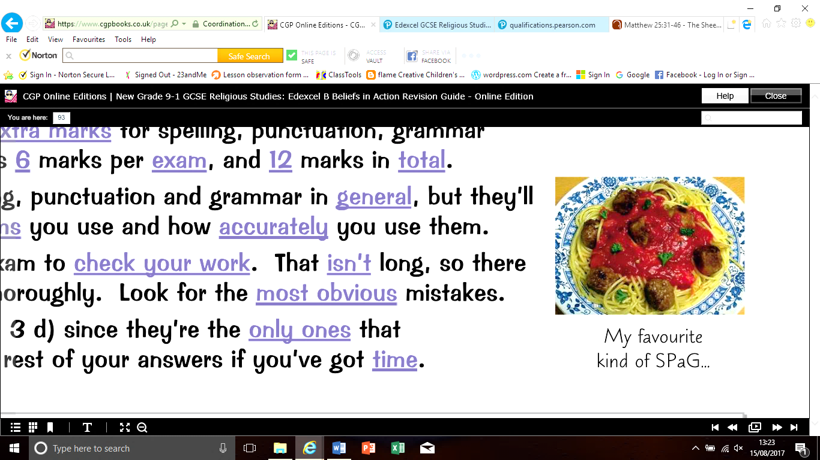Some Part (d) Questions Have 3 Extra Marks for SPaG

* Part (d) of questions 1 and 3 has 3 extra marks for spelling, punctuation, grammar and specialist terminology. So that’s 6 marks per exam, and 12 marks in total.

* The examiner will look at your spelling, punctuation and grammar in general, but they’ll also look at how many technical terms you use and how accurately you use them.

* Leave 5 minutes at the end of the exam to check your work. That isn’t long, so there won’t be time to check everything thoroughly. Look for the most obvious mistakes.

* Start by checking questions 1 d) and 3 d) since they’re the only ones that award SPaG marks. Only check the rest of your answers if you’ve got time.

Introduction to Christianity

Christianity is based on the belief in Jesus Christ being the Son of God. It is the main religion in Britain.

The Bible is the Christian Sacred Text

The Bible is divided into two main parts — the Old and New Testaments:

[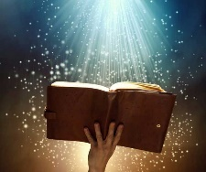](http://www.google.co.uk/url?sa=i&rct=j&q=&esrc=s&source=images&cd=&cad=rja&uact=8&ved=0ahUKEwjutbamxNvVAhUCUhQKHR2bDDkQjRwIBw&url=http://www.bibleinfo.com/en/topics/bible-promises&psig=AFQjCNGJ7q6uJv9lholK1HAKjBLZmic71g&ust=1502965285740265)* Depending on the version, the Old Testament has at least 39 books, which include the Creation story and the Ten Commandments. These 39 books are the Jewish scriptures — they are also considered sacred by Jews.

* The New Testament is the specifically Christian part of the Bible. Its 27 books include the 4 Gospels (Matthew, Mark, Luke and John), which are accounts of Jesus’ life. The Acts of the Apostles and the letters of St Paul describe the early years of Christianity.

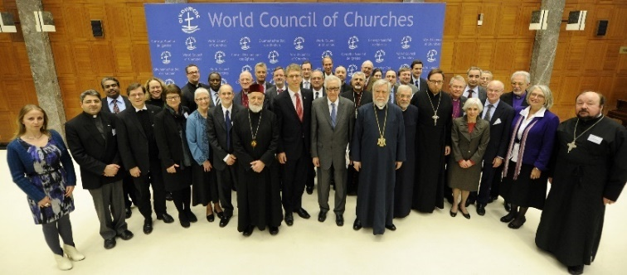Christianity is Divided into Different Traditions

The different branches of Christianity are called **denominations**. They share key beliefs, but interpret some points of the faith differently and worship in different ways.

* **Roman Catholics** respect the authority of the Bible and Church tradition, plus the authority of the Pope and his teachings. The seven sacraments (which include the Eucharist) are an important part of their faith.

* **Protestants** base their beliefs and practices on the Bible, rather than Church tradition or the teachings of the Pope. In England and Wales, Protestant denominations that are not part of the ‘**Anglican** Communion’ are often called ‘Nonconformists’. These include **Methodists, Baptists, Pentecostals, The Society of Friends (Quakers) and the Salvation Army**.

The **Church of England** has both Roman Catholic and Protestant features. Its beliefs are set out in the **39 Articles**. **Anglicanism** is the worldwide ‘communion’ of Churches in fellowship with the parent Church of England.

* **Orthodox Christians** are found mainly in Eastern Europe, Russia and Greece. They also have 7 sacraments, and honour (but don’t worship) icons — pictures of Saints.

There are Many Beliefs About the Nature of God

Christianity is a monotheistic (one god) religion. The Ten Commandments say “You shall have no other gods” (Exodus 20:3). Christians believe God has the following characteristics:

[](http://www.google.co.uk/url?sa=i&rct=j&q=&esrc=s&source=images&cd=&cad=rja&uact=8&ved=0ahUKEwiRlpXyxdvVAhUDzxQKHcVGDhMQjRwIBw&url=http://www.dynescc.ca/&psig=AFQjCNFvqimaPTGvxZJ6P3IkZNU9txZ4-Q&ust=1502965746418495)* Omnipotent — God is all-powerful, although he still allows each person free will.

* Omni-benevolent — God is loving and caring: “For God so loved the world that he gave his one and only Son” (John 3:16). Christians try to follow his example in their actions.

* Just Judge — God judges people’s actions fairly. Those who reject him and live sinful lives will be punished, as shown in the Parable of the Sheep and Goats in Matthew 25:31-46. But God forgives people who are sorry for what they’ve done and become faithful to him — the Parable of the Lost Son (Luke 15:11-32) shows God will forgive anyone who returns to his ways.

* Omniscient — God knows everything - in the past, present and future.

* Eternal — God has always existed, and he will continue to exist forever.

* Transcendent — God is beyond this world - he doesn’t depend on it to exist.

* Immanent — But God is present in the human world, and takes an active role in humanity.

* Personal — God is a ‘person’, albeit an almighty and divine person. If God is personal, then a relationship is possible through prayer - which can be a ‘conversation’ with God.

SECTION 1: CHRISTIAN BELIEFS

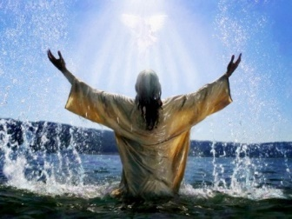The Trinity

Although Christians believe in **one God**, they also believe that God exists in **three ‘persons’** — **the Father, the Son** (Jesus) and the **Holy Spirit**. The importance of all three is shown in the Bible: **Matthew 3:16-17** describes how at **Jesus’s baptism**, Jesus “...saw the **Spirit** of God descending like a dove and alighting on him. And a **voice from heaven** said, ‘This is **my Son**, whom I love; with him I am well pleased.’ ”

In Philippians 2:6, Paul described **Jesus as having “equality with God**”.

The Trinity is Explained in the Nicene Creed

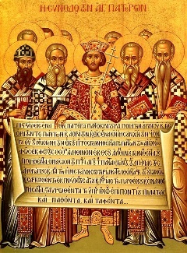* In 325AD, Church leaders from around the world gathered at the Council of Nicaea. They produced a creed - a statement of beliefs - known as the **Nicene Creed**. It describes **how Christians see God**: “We believe in one **God, the Father**, the Almighty, maker of heaven and earth... We believe in one Lord, Jesus Christ, the only **Son of God**... of one Being with the Father... was made man... he suffered death and... he rose again... We believe in the **Holy Spirit**... the giver of life, who proceeds from the Father and the Son... who has spoken through the prophets.”

* Before this, not everyone had agreed that the **Son of God (Jesus) was one with God**, rather than having been made by God. Now they agreed that **he was equally important**.

* The importance the early Church placed on the Trinity in the Nicene Creed means it is a key belief for most Christians — it is usually recited during the Eucharist service. But some groups, such as **Jehovah’s Witnesses and Mormons, don’t believe in the Trinity.**

Christians see the three parts of the **Trinity** as having **different characteristics and roles**:

The Father…

• Helps Christians to understand the power and creativity of God and his care for the world and its people - God is

not a creator who creates and then leaves his creation to get on with things, he has a relationship of love and

care with his creation.

• In the Lord’s Prayer, Christians learn that God will provide their daily bread and protect them from evil precisely because he is ‘our Father’. Because God is the Father, Christians can turn to God as they would to a human father when they are in need.

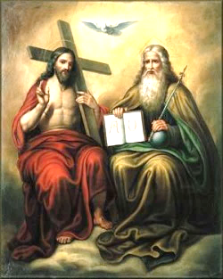The Son…

• Helps Christians to understand the love of God. In his life and teachings, Jesus showed God’s love by healing people and feeding people. In his death, he showed how much God loves the world.

• Christians believe Jesus is the incarnation of God in human form. He is seen as both divine and human — the immanent and personal part of God, who understands human suffering.

• Christians believe that Jesus provides a model for Christian behaviour in obedience to God the Father. The Gospels contain a record of his life and teachings, and are an important source of guidance for Christians on how they should live their lives.

The Holy Spirit…

• Helps Christians to understand the presence of God in the world. Christians believe that the Holy Spirit is the means by which God communicates with humans, revealing God’s presence in the world.

• Christians believe that through the presence of the Holy Spirit in their lives, God can strengthen and empower them today. The Catechism of the Catholic Church 736 says, “By this power of the Spirit, God’s children can bear much fruit.”

• Before his death, Jesus promised his disciples: “I will ask the Father, and he will give you another advocate to help you and be with you for ever — the Spirit of truth” (John 14:16-17).

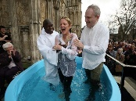How is the Trinity shown in belief and worship?

* Holy Communion * Making the sign of the cross * Religious leaders’ preaching

* Christening/Baptism * Marriage service

The Oneness of God - even though there is the trinity

Believing in the oneness of God is the basis of Christianity. But where does this idea come from?

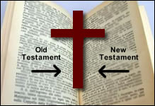- The teachings of the Bible show clearly that there is only one God.

- The belief in the oneness of God is the first of the Ten Commandments, which all Christians

accept as God’s rules about belief and behaviour.

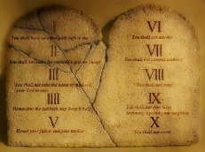- When asked what was the greatest commandment, Jesus replied, ‘The most important one is

this, ‘Hear O Israel, the Lord our God, the Lord is one’. (Mark 12:29)

- The oneness of God is the teaching of the Church as seen in the Creeds, the decisions of

Church Councils and the writings of Church leaders.

- The oneness of God is shown in the universe. They believe that the fact it is a universe working

to one set of laws means it was created by one god.

the Trinity is important because:

• it brings humanity face to face with the mystery of God

• it helps humanity recognise the God they meet in the Bible, in history and in their own lives

• it helps humanity understand God's complexity, otherness and mystery

• it helps humanity worship God

• it steers humanity away from wrong ideas of God, such as a patriarchal/hierarchical god, a god who can be logically understood

• it is the foundation of much Christian worship and liturgy

• it helps humanity understand its own nature as made in the image of God

• it provides a model for human relationships, both as individuals and in community.

Creation

The story of creation can be understood in different ways. Some take it literally, for others it’s a metaphor.

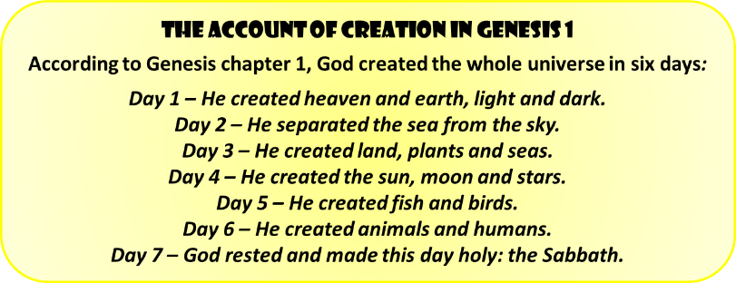The Bible Describes how God Created the Universe

* **Genesis chapter 1** says that God created everything…

* Christians see **God the Father** as the creator, but the Bible also describes how the other persons of the Trinity were involved. God created the world by acting through the **Holy Spirit**: “...the Spirit of God was hovering over the waters. And God said, ‘Let there be light,’ and there was light” (**Genesis 1:2-3**).

* The role of the **Son of God** is described in the Gospel of John. He uses the phrase ‘the Word’, but it is clear he is referring to Jesus as he later says: “The Word became flesh and made his dwelling among us” (John 1:14). John makes it clear that Jesus was vital for creation: “In the beginning was the Word, and the Word was with God, and the Word was God. He was with God in the beginning. Through him all things were made; without him nothing was made that has been made” (**John 1:1-3**).

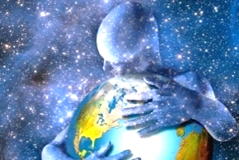

It Explains How Human Beings were Created

* The creation of human beings is described in **Genesis chapters 1 and 2**. The first two humans were Adam and Eve, and they lived in the Garden of Eden.

* Genesis chapter 1 says “So God created mankind in his own image, in the image of God he created them; male and female he created them” (Genesis 1:27).

[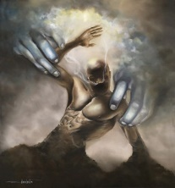](http://www.google.co.uk/url?sa=i&rct=j&q=&esrc=s&source=images&cd=&cad=rja&uact=8&ved=0ahUKEwjYt9m2moPPAhUH2xoKHfEZBOcQjRwIBw&url=http://sdrministries.org/nature/animals.html&psig=AFQjCNHti_WWcwpYWlL4su7brnDvFJk87Q&ust=1473542150002187)* Genesis chapter 2 says “…the Lord God formed a man from the dust of the ground” (Genesis 2:7) and “…made a woman from the rib he had taken out of the man” (Genesis 2:22).

* The fact that God created humans in his image is important. Because of this, Christians believe that humans are special. They think humans should behave like God by being loving and fair. It also shows that humans are important to God, and so everyone should be treated with respect.

* In **Genesis 1:28**, God told Adam and Eve to “Rule over the fish in the sea and the birds in the sky and over every living creature that moves on the ground”. Some Christians believe God gave humans **dominion** (power) over his creation and they can use it as they like. However, **Genesis 2:15** says “The Lord God took the man and put him in the Garden of Eden to work it and take care of it”. Many Christians interpret this as humans having **stewardship** of the Earth — God expects them to care for it.

Christians Interpret the Creation Story differently

* **Literalists** take the creation story literally — they are also known as **Creationists**. They believe that the process took six days, and humans are descended from Adam and Eve.

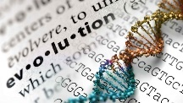* **Liberal Christians** view Genesis as a symbolic description — they acknowledge God as the creator, but are open to other ideas, such as the Big Bang theory and Evolution. These theories can offer more information to Christians about how God made the universe. The **Roman Catholic Church** has accepted both theories.

* The **creation story is important** to Christians as it can help them further understand God’s nature: God is eternal as he made time, and was present ‘prior’ to it. He is omnipotent as he created the universe through words. God’s omni-benevolence can be seen through creation too as he brought humankind to life and gave them the world.

Jesus Christ and Salvation

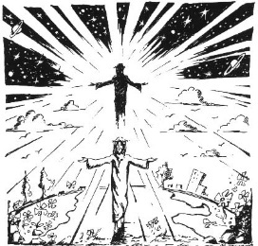God Became Human at the Incarnation

* The **Incarnation** was the act by which God became a human being as Jesus Christ. John’s Gospel describes Jesus as the Word of God, made human: “The Word became flesh and made his dwelling among us. We have seen his glory, the glory of the one and only Son, who came from the Father, full of grace and truth” (**John 1:14**).

* Angel Gabriel told Mary that she would have a son — and that “the holy one to be born will be called the **Son of God**” (Luke 1:35).

* This belief is stated in the **Nicene Creed**: “he... was incarnate from the **Holy Spirit** and the Virgin Mary and was made man”.

* Christians don’t believe that Jesus was ‘half God and half man’ — he was **fully both**. The Bible describes how God “appeared in the flesh” (**1 Timothy 3:16**).

* Jesus is referred to as **‘Christ’ or ‘Messiah’** — the ‘Anointed One of God’.

* After being baptised by John the Baptist, Jesus began teaching. He had many followers, including 12 chosen disciples. Some of his key teachings are in the Sermon on the Mount (Matthew 5-7) — he taught how the poor and meek are highly valued by God, and how peacemakers are blessed. He also taught the importance of kindness, such as in the Parable of the Good Samaritan (Luke 10:30‑37). He performed miracles such as healing the sick, showing that he was the **Son of God** and demonstrating **God’s love**.

Why is the Incarnation important?

* It shows Christians that **God** caredso much about the world that he sent his **Son** to teach them how to live.

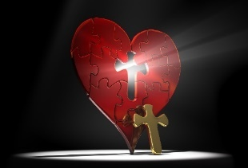- It is the basis of the Christian faith: without the incarnation of Jesus Christ, the **Son of God**,

there would be no Christianity.

- In Jesus, the incarnate **Son of God**, humans can see what God is like. It is hard for humans to

understand an infinite, non-material, omnipotent being, but an incarnate God brings God closer to

human understanding.

- Through the Incarnation, God began the process of salvation from sin, so making it possible for

humans to have a full relationship with him and go to Heaven after death.

Jesus was Crucified and Resurrected (See your book for more information on Jesus’ Last Days)

**The Last Supper, Jesus’ Arrest and Trial**

1) Shortly before his death, Jesus and his disciples ate their Passover meal in Jerusalem. It was their final meal together and became known as the **Last Supper**.

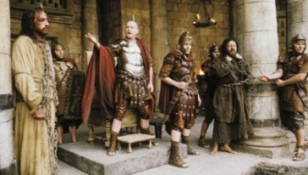2) At the meal, Jesus gave the disciples bread saying “this is my body”, and wine saying “this is my blood” (Mark 14:22-24). Luke’s Gospel tells us he said “do this in remembrance of me” (**Luke 22:19**). These words are important to many Christians today who remember Jesus with bread and wine through the **Eucharist**.

3) At the Last Supper, Jesus also washed his disciples’ feet, which teaches Christians about how important it is to serve others.

4) Next, Jesus went to pray in the Garden of Gethsemane, where he was **arrested** after Judas betrayed him. The authorities felt threatened by Jesus — earlier that week, crowds had called him the ‘King of Israel’.

5) He was put on **trial** before the **Jewish high priest** and found guilty of blasphemy. Then Jesus was tried before the **Roman governor, Pilate** — he offered to release Jesus, but the crowd said “Crucify him!” (Mark 15:13). He was flogged, before being sent to die.

**Crucifixion**

1) Jesus was **crucified** at a place called Golgotha, next to two robbers. A sign was fixed to Jesus’ cross that read ‘The King of the Jews’, to record the charge against him. Passers‑by threw insults at Jesus, saying that he could save others, but couldn’t save himself.

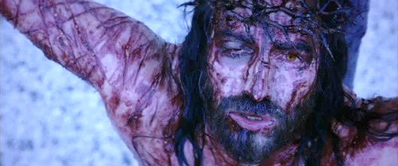2) In his suffering, Jesus cried out, “My God, my God, why have you forsaken me?” (Mark 15:34). This shows that Jesus understands how people can feel abandoned in their suffering.

3) Christians also believe the crucifixion helped to repair the relationship between God and mankind — the **atonement**.

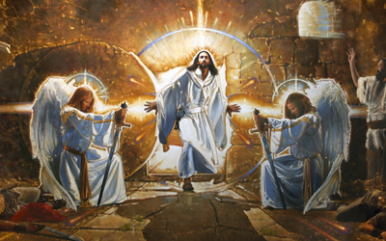**Resurrection**

1) After the crucifixion, Jesus’s body was put in a tomb. But he was **resurrected** (brought back to life), and his tomb was found empty.

2) Jesus talked to two women and told them “Go and tell my brothers to go to Galilee; there they will see me” (Matthew 28:10).

3) The resurrection is important to Christians as it shows them that there is life after death — death becomes less frightening.

4) It shows them just how powerful God is. This power that raised Jesus from the dead gives people the strength to live Christian lives.

5) Christians also see the resurrection as further proof that Jesus is the **Son of God** as he was “...appointed the Son of God in power by his resurrection from the dead...” (Romans 1:4). This strengthens people’s faith. “...Why do you look for the living among the dead? He is not here; he has risen!” (**Luke 24:5-6**).

**Roman Catholics** refer to the crucifixion, resurrection and ascension of Jesus as ‘The Paschal Mystery’.

Jesus Christ and Salvation

**Salvation** is needed before Christians can go to Heaven, and Jesus’ actions made it possible.

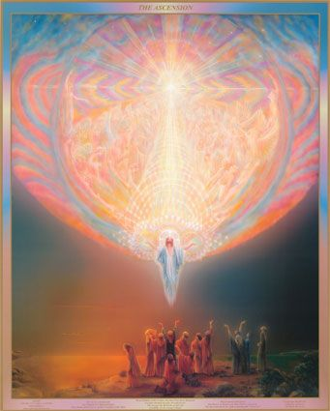**Jesus going up into Heaven is Called the Ascension**

* Over the 40 days after the resurrection, many of Jesus’ disciples said they had met him alive in various places around Jerusalem.

* Then, Jesus ‘**ascended into Heaven’** to be with **God the Father** once again. He had done what he was sent to Earth to do, and it was time for him to go back to God.

* In John 14:2, Jesus tells his disciples he will “prepare a place” for them in Heaven. 1 John 2:1 says that, in Jesus, Christians have an ‘advocate’ with God (someone who will look out for them).

* Pope Benedict XVI said that since Jesus was human and went to be with God, the ascension shows there’s a place for all human beings with God.

* The Ascension shows Jesus’ power — he is now “at the right hand of the mighty God” (**Luke 22:69**). “While he was blessing them, he left them and was taken up into heaven” (**Luke 24:51).**

**Jesus Died to Save Humanity**

* ‘**Original sin’** means that everyone is born capable of sinning. Many Christians believe that Jesus’ suffering and death won forgiveness for everyone and ensured their **redemption** (freeing them from sin).

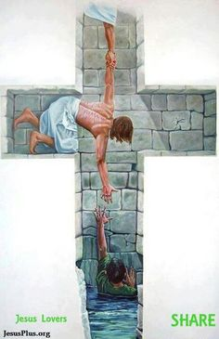* They believe that Jesus was perfect (without sin), but God placed all the sins of the world on him at his crucifixion. Romans 3:21-26 teaches that his sacrifice paid for their sins, so long as they have repented (said sorry for their sin and changed their life) and have faith in him.

* Jesus’ actions brought about the **reconciliation** between God and humanity — known as the **atonement**.

* His power and goodness were so great that after he was crucified, death couldn’t keep hold of him.

* However, not all Christians believe that Jesus had to die to pay for people’s sins:

* **1 Corinthians 13:5** says that love “keeps no record of wrongs”. Many Christians think that Jesus’ death wasn’t required for a loving and merciful God to be able to forgive people’s sins.

• Some people argue that it was Jesus’ ministry that showed people how to be free from sin — he showed them how to live their lives in a godly way.

• **Roman Catholic and Orthodox Christians** believe that they can receive the salvation offered by Jesus’ death by:

- receiving the sacraments of baptism and confirmation - receiving the sacrament of confession - receiving the sacrament of the Eucharist (Holy Communion) - leading a Christian life.

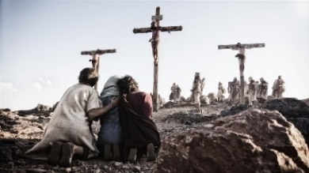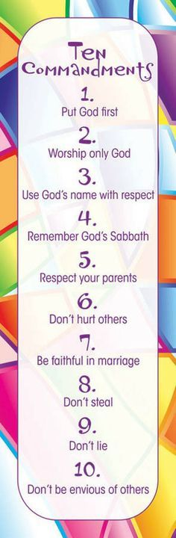* Some say Jesus’ death shows God’s love for humankind through his willingness to suffer and die as humans do. His resurrection showed how God could triumph over sin and death, so people don’t have to fear evil: “For God so loved the world that he gave his one and only Son, that whoever believes in him shall not perish but have eternal life. For God did not send his Son into the world to condemn the world, but to save the world through him” (**John 3:16-17).**

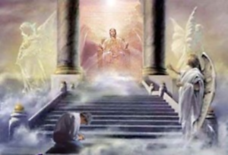**Christians Must Seek Salvation to Get to Heaven**

* **Salvation** means the soul being saved from death and sin, allowing it to reach Heaven. For this to happen, Christians believe they must have faith in Jesus: “Salvation is found in no one else...” (**Acts 4:12**).

* Salvation is only possible through God’s **grace** — God showing favour to those who haven’t earned it: “For it is by grace you have been saved, through faith... it is the gift of God” (Ephesians 2:8).

* But people can’t just say they believe — if they’re a true believer they’ll try to live a Christian life. The Bible contains many **laws**, such as the Ten Commandments, which provide Christians with guidance on how they should behave. Everyone will **sin**, but the laws mean they’ll “become conscious of ... sin” (Romans 3:20) and “turn to God in repentance” (Acts 20:21).

* The **Holy Spirit** helps Christians to follow the teachings of God and his laws and keep their faith, helping them to find salvation.

ESCHATOLOGY: The Afterlife

What people believe will happen to them after death can influence the way they live their lives.

Christians Believe in Heaven and Hell

* Life after death is the idea that, although your body may die and decay, your soul can live on.

* Christianity teaches that the soul lives on after death - **immortality of the soul** - and that the body will be **resurrected** (brought back to life) for **Judgement Day**, just as Jesus was resurrected after his crucifixion.

[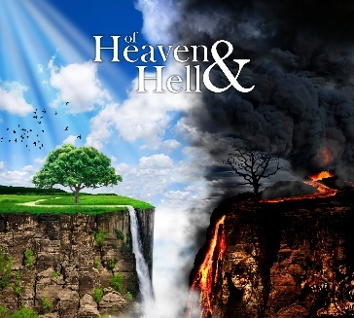](http://www.google.co.uk/url?sa=i&rct=j&q=&esrc=s&source=images&cd=&cad=rja&uact=8&ved=0ahUKEwihjMXL5tvVAhVD0RQKHcxPDKoQjRwIBw&url=http://www.zorahdesign.com/ofheavenandhell/&psig=AFQjCNHvIP0ShqcdbLfClexw4Aoix9mRfg&ust=1502974489747535)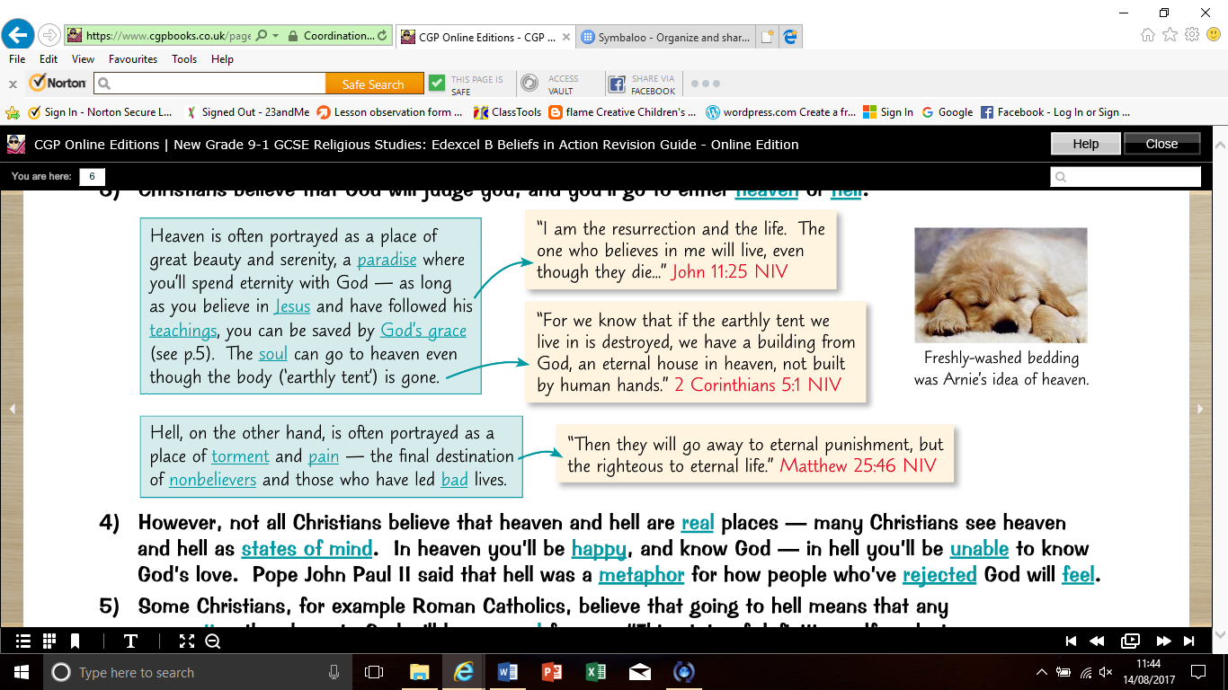* Christians believe that God will judge you, and you’ll go to either **Heaven** or **Hell**:

* However, not all Christians believe that Heaven and Hell are real places — many Christians see Heaven and Hell as states of mind. In Heaven you’ll be happy, and know God — in Hell you’ll be unable to know God’s love. **Pope John Paul II said that Hell was a metaphor** for how people who’ve rejected God will feel.

* **Roman Catholics** believe that going to Hell means that any connection they have to God will be severed forever: “This state of definitive self‑exclusion from communion with God... is called ‘hell’ ” (**Catechism of the Catholic Church 1033**).

* Some believe God wouldn’t punish people for eternity. A few believe that those who God finds unacceptable will be annihilated. In a report called ‘The Mystery of Salvation’, senior members of the **Church of England** said that for those people “the only end is total non‑being”. Others think a loving God wouldn’t allow anyone to go to Hell.

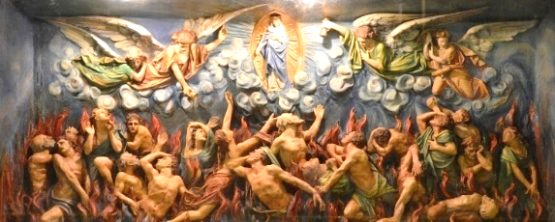

Purgatory **Roman Catholics** believe in a place, or state of existence, called **Purgatory**. Here sins are punished and the person must “undergo purification” (**Catechism of the Catholic Church 1030**) before the soul can move on to Heaven. Protestants believe this isn’t in the Bible, so they reject it.

Christians Believe Resurrection Happens at the Last Judgement

* Many Christians believe that Jesus will return to Earth in the **Second Coming** (Parousia), and everyone who has died will be **resurrected**: “in Christ all will be made alive” (1 Corinthians 15:22).

* Some believe that all of humanity will then be judged at the Last Judgement. Those that God finds acceptable will enter Heaven — the rest will go to Hell, as in the **Parable of the Sheep and Goats (Matthew 25:31-46**).

[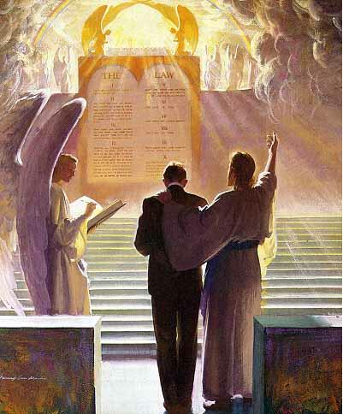](http://www.google.co.uk/url?sa=i&rct=j&q=&esrc=s&source=images&cd=&cad=rja&uact=8&ved=0ahUKEwir1MLT6dvVAhUFthQKHf0rBBkQjRwIBw&url=http://www.christconnection.net/id5.html&psig=AFQjCNFz4W1axLaOpU3hNUn3VSbmlRtKng&ust=1502975346183816)- “Christ... ascended into Heaven, and there sitteth, until he return to judge all Men at the last day.” **39 Articles IV**

[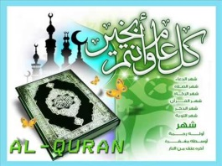](https://www.google.co.uk/url?sa=i&rct=j&q=&esrc=s&source=images&cd=&cad=rja&uact=8&ved=0ahUKEwjKzo23qO3VAhWBWRQKHR3jB40QjRwIBw&url=https://www.pinterest.co.uk/explore/surah-al-qadr/&psig=AFQjCNHG2K7jdXHHUV7zyOKPUzzqW6EJZg&ust=1503576161141956)- “For we must all appear before the judgment seat of Christ, so that each of us may receive what is due to us for the things done while in the body, whether good or bad” (**2 Corinthians 5:10**).

* **Roman Catholics** believe in a **personal day of judgement** straight after a person dies — their actions will be judged and they’ll go to Heaven or Hell straight away, then they’ll be judged again at the Last Judgement, and will re-enter Heaven or Hell in their resurrected forms.

* Others don’t believe in a personal judgement — the soul must wait to be judged at the Last Judgement.

Remember: You need to be able to compare Christian beliefs about the afterlife with those of Islam…

Al-Qadr means Predestination

* **Al-Qadr** is the idea that Allah has decided everything that will happen. This idea appears in teachings such as Sahih al-Bukhari 78:685, in which Muhammad said vowing to do something “does not bring about ... anything [Allah] has not decreed” — humans can’t choose to do something Allah hasn’t chosen for them.

* This might seem to be contradicted by the idea of the **Day of Judgement** when Allah will judge people on the basis of their actions. That suggests people have **free will** and can choose how they act — there’d be no point judging them on their actions if what they did had already been decided by Allah.

* However, many Muslims believe in a mix of these two ideas:

- **Sunnis** tend to believe **Allah knows everything that’s going to happen** — he’s above normal laws of time, so knows what humans will choose before they’ve chosen it. It’s believed humans choose their actions, but Allah has made it impossible that they’ll choose anything other than what he’s decided. Some think once someone’s chosen to act, the act becomes ‘theirs’ so they can be judged for it.

- **Shi’as** focus a bit more on **free will**. They often believe Allah has ultimate control and the power to change things in the world if he wants, but that people’s lives are usually determined by their choices. Like Sunnis, they tend to believe Allah knows what’s going to happen as he is outside ‘human’ time — but for Shi’as, what happens is what people choose for themselves.

* To some Muslims, the idea of **al-Qadr** is comforting — if something bad has happened, it’s reassuring to feel it’s part of **Allah’s plan**. Some people like to feel that they’re **guided to do Allah’s will by al-Qadr**.

[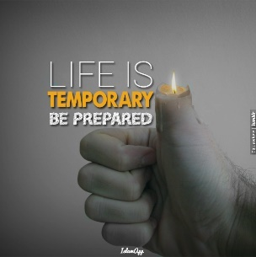](http://www.google.co.uk/url?sa=i&rct=j&q=&esrc=s&source=images&cd=&cad=rja&uact=8&ved=0ahUKEwjkk_qNqu3VAhUI7RQKHUjcBBoQjRwIBw&url=http://www.quran-o-sunnat.com/al-akhirah-the-hereafter/&psig=AFQjCNHNrs2cHwXBIMRIvEpV9QlM6FlKPg&ust=1503576714178921)[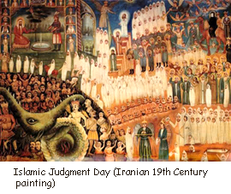](http://www.google.co.uk/url?sa=i&rct=j&q=&esrc=s&source=images&cd=&cad=rja&uact=8&ved=0ahUKEwj2ubj1qO3VAhUBWhQKHfNjCU8QjRwIBw&url=http://islammonitor.org/index.php?limitstart%3D1040&psig=AFQjCNEBwvWHZmP2izWR7EKrFe_YSUNFPw&ust=1503576442793873)

Yawm ad-Din is the Day of Judgement

* On **Yawm ad-Din**, Allah decides how people will spend the afterlife, based on their behaviour during their lives. It’s then too late to beg forgiveness for any wrongdoing.

* **Allah will judge everyone** — not just Muslims. On Yawm ad-Din, the dead will be **resurrected** to join those still living. Everyone will receive a record of their good and bad deeds, on which they’ll be judged. “We will call forth every people with their record [of deeds].” Qur’an 17:71

* The idea of judgement is important as it encourages Muslims to live their lives in a good way. It can be comforting to think bad people will be punished. Other Muslims think it’s best to concentrate on this life — they think people should do good things anyway, not just because they’re focusing on their afterlife.

* **Intentions** are also important — intending to do something good counts, but intending to do something bad but not doing it doesn’t count against you (Sahih Muslim 1:233).

Al-Akhirah Means the Afterlife

* Belief in the afterlife — **al-Akhirah** — is a key part of Islam. The afterlife is where people go after the Day of Judgement.

* The reward for good people will be entry into **jannah (Paradise)** — this is a place of peace, happiness and beauty. The Qur’an refers to Paradise as “Gardens of Pleasure” (Qur’an 31:8). “...for one whose scales are heavy [with good deeds], He will be in a pleasant life. ...for one whose scales are light, His refuge will be an abyss.” Qur’an 101:6-9

* For those who have done bad deeds, the punishment is **jahannam (Hell).** The Qur’an describes jahannam as a place of scorching fire and boiling water. Here, those who have ignored Allah’s

teaching and failed to act righteously will be punished. **Allah is merciful**

though, so they may eventually be sent to Paradise.

* The Qur’an sometimes mentions a ‘**barrier**’ between this world and the next

called **barzakh**, where people’s souls stay from the time they die until Yawm

ad-Din. Many Muslims focus more on jannah and jahannam than

barzakh.“...behind them is a barrier until the Day they are resurrected.”

Qur’an 23:100

Which beliefs are the same as these in Christianity and

which are different? Create a table or lists.

Why are Teachings about Life After Death Important to Christians today?

* Christians will try to live a good Christian life following the teachings of the Bible and the Church, so that they please God and are rewarded in Heaven.

* The **Catholic Church** teaches that those who die with unforgiven sins will go to **Purgatory** to be purified before they can reach Heaven. Clearly, these teachings mean that Christians will try to avoid committing sins in their lives so that they will go to Heaven.

* Beliefs about life after death give Christians’ lives meaning and purpose. A life after death, where people will be judged on how they live this life, with the good rewarded and the evil punished, makes sense of this life.

Evil and Suffering

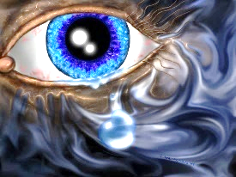Free Will Led to Evil Entering the World

* Christianity teaches that evil entered the world as a result of Adam and Eve giving in to temptation in the Garden of Eden — they disobeyed God by eating the fruit of the tree of knowledge. This switch from a perfect world to one containing evil is known as ‘**The Fall**’: “When the woman saw... the fruit of the tree... she took some and ate it. She also gave some to her husband... and he ate it.” Genesis 3:6

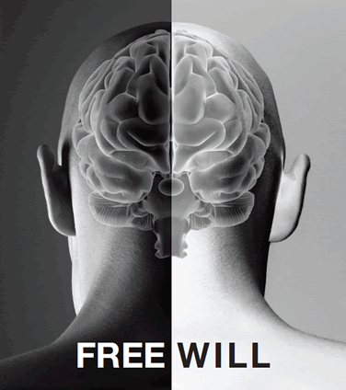* After The Fall, every human being was born with a flawed nature, capable of causing suffering — this is the idea of **original sin**.

* Christians believe God created humans with **free will** — it’s up to them to choose whether they perform evil deeds or not, just as it was up to Adam and Eve whether to give in to temptation or not. Good is the opposite of evil, and since God is good, Christians try to follow his example.

Suffering can be Human-Made or Natural

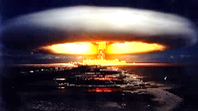**Moral (human-made) Suffering:**

* This is when suffering is brought about by the cruel actions of people.

* This includes things like **murder, war, rape and torture**.

* The person causing the suffering is able to make a choice about what is morally right or wrong.

**Natural Suffering:**

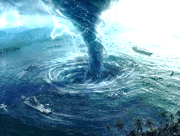* This kind of suffering is caused by the world in which we live, and is no one’s ‘fault’.

* This includes things like **disease, floods, earthquakes and hurricanes.**

* However, many recent natural disasters may have been caused by human interference in the

natural world, raising the question of whether that makes those events human‑made.

Evil can Lead People to Question their Faith or doubt God’s Existence

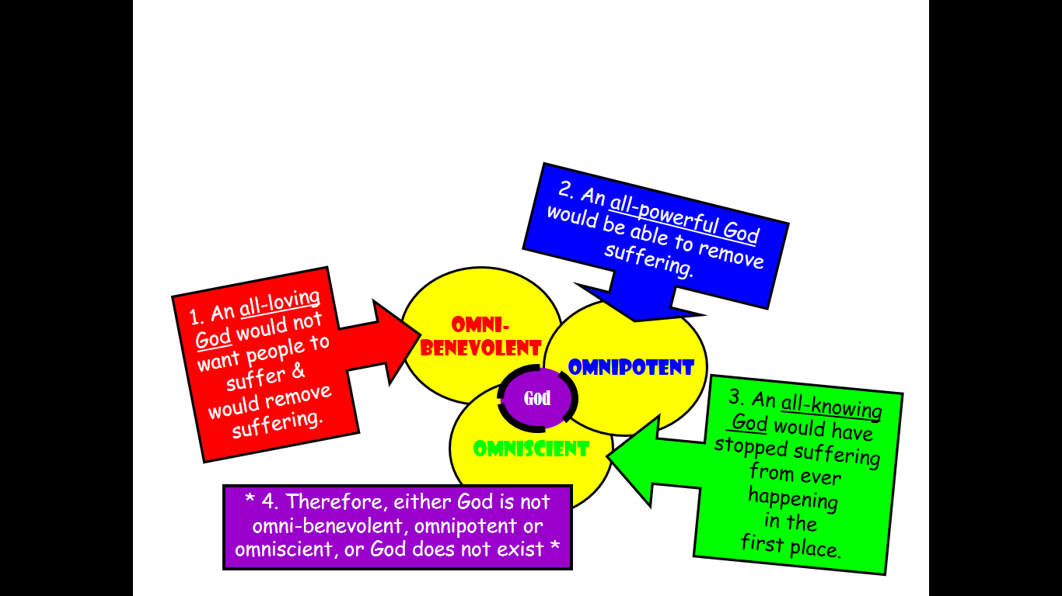* Some might say that since suffering exists, God can’t be both **omni-benevolent** and **omnipotent** — a loving and all‑powerful God wouldn’t allow it to happen. They might argue that he doesn’t exist, or that he can’t have the characteristics that believers say he has.

* But others would say that although God has these characteristics, he gave people **free will** and so doesn’t interfere: “the Lord is compassionate and gracious, slow to anger, abounding in love... he does not treat us as our sins deserve...” (**Psalm 103:8-10**).

How Christians respond to evil and suffering:

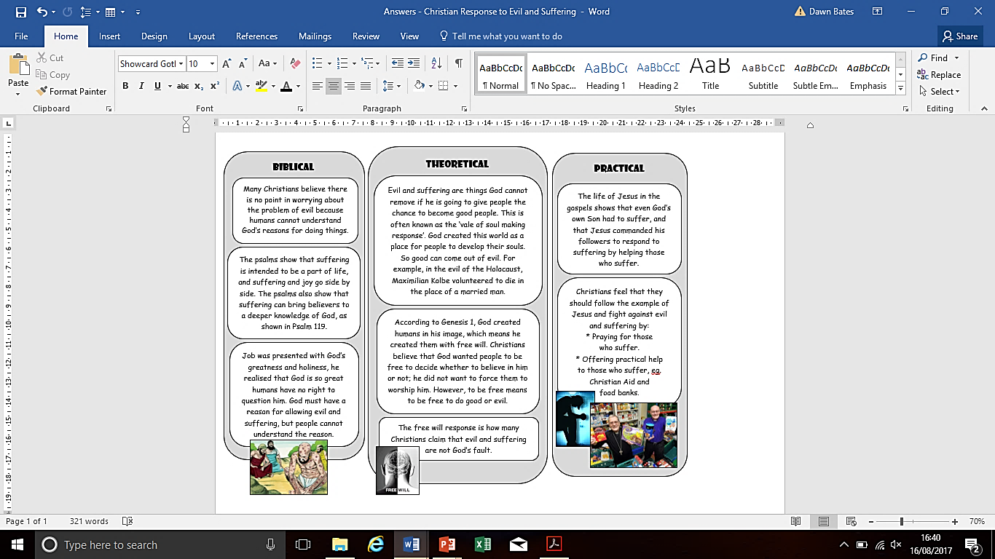

“I know, Lord, that your laws are righteous, and that in faithfulness you have afflicted me. May your unfailing love be my comfort...” Psalm 119: 75-76

“Though he slay me, yet will I hope in him...” (Job 13:15).



An Example of the Success of Solutions to the Problem of Evil & Suffering

**How Christian Aid is trying to end the suffering of world poverty:**

1. Speaking out on behalf of poor communities to bring social justice – E.g. involved in ‘Make Poverty History’ campaign in 2005. It wants to help cancel the debt that poor countries owe to rich countries.

2. Development Programmes – E.g. In the Gaza Strip they support agricultural production and long-term food security for unemployed daily wage earners who cannot get their goods to markets because Gaza’s borders are closed for long periods of time.

3. Disasters and emergencies – they have a disaster fund to deal with natural disasters and refugees. Emergency aid includes sending food and water, antibiotics, shelters to victims of disasters such as the tsunami in South East Asia.

test 1: Christian beliefs

1. What is the Trinity. (3 marks)

2. Where is the importance of all three parts of the Trinity shown? (2 marks)

3. What important document lays out Christian beliefs on the Trinity? (1 mark)

4. What was the issue concerning Jesus before this document was produced? (2 marks)

5. Name two Christian groups that do not believe in the Trinity. (2 marks)

6. State two characteristics or roles that the Father has. (2 marks)

7. State two characteristics or roles the Son has. (2 marks)

8. State two characteristics or roles the Holy Spirit has. (2 marks)

9. State three ways that the Trinity is shown in belief and worship. (3 marks)

10. Why do Christians believe in the oneness of God despite the Trinity? (2 marks)

11. Why is the Trinity so important to most Christians? (2 marks)

12. Fill in the blanks: ________ chapter 1 says God created the whole universe in ___ days and on the seventh He ______. Day six was the climax as on this day God made ________. (4 marks)

13. What did God the Father act through to create the world and how do we know this from Genesis 1:2-3? (1 mark)

14. What does John call Jesus, and what does John say so that we know that Jesus was vital for creation? (2 marks)

15. What was mankind made in which sets us apart from animals. Why is this important? Name one reason. (2 marks)

16. What’s the difference between ‘dominion’ of the Earth and ‘stewardship’ of the Earth? (2 marks)

17. Name three ideas that Literalists, also called Creationists, have about creation. (3 marks)

18. Liberal Christians have three key beliefs about creation – what are they? (3 marks)

19. Why is the creation story important to Christians? (3 marks)

20. What is the incarnation? (1 mark)

21. How do we know this from John 1:14? (1 mark)

22. Jesus was fully what and what? Where do we get this idea from in the Bible? (2 marks)

23. What does ‘Christ’ and ‘Messiah’ mean? (1 mark)

24. Give two reasons why the Incarnation is important? (2 marks)

25. Why is the Last Supper important for Christians today? (3 marks)

26. Where was Jesus arrested, who betrayed him, and how did the authorities feel which led to Jesus going on trial? (3 marks)

27. What was Jesus found guilty of by the high priest, but why would Pilate try and release Jesus? (2 marks)

28. What do Christians believe the crucifixion helped to repair and what is the technical name for this? (2 marks)

29. What does resurrected mean? (1 mark)

30. Give two reasons why the resurrection is important to Christians. (2 marks)

31. Complete the quote from Luke 24:5-6: “...Why do you look for the living among the dead? __ __ __ ___; __ ___ ______!” (1 mark)

32. What is ‘The Paschal Mystery’ and who uses this term? (2 marks)

33. What is the Ascension and how many days after the resurrection did it occur? (2 marks)

34. What does the Ascension show? (2 marks)

35. What does ‘original sin’ mean? (1 mark)

36. What does redemption mean and how did Jesus win this for humanity? (2 marks)

37. Not all Christians believe that Jesus had to die to pay for people’s sins. Give two reasons why. (2 marks)

38. What four things does John 3:16 & 17 say God did? (4 marks)

39. What does salvation mean? (1 mark)

40. How can salvation happen? Give the quote too. (2 marks)

41. How is salvation possible? (1 mark)

42. What does the answer to question 41 mean? (1 mark)

43. What is the most important set of laws for Christians and why are they important? (3 marks)

44. What does the Holy Spirit help Christians to do? (2 marks)

45. Why does it matter if someone believes in life after death? (1 mark)

46. What does immortality of the soul mean? (1 mark)

47.When will people’s bodies be resurrected and where will they end up? (3 marks)

48. What does the quote from 2 Corinthians 5:1 mean? (3 marks)

49. What divergent views do some Christians have on Heaven and Hell? (2 marks)

50. What is Purgatory and who believes in it? (2 marks)

51. Why do Protestants reject Purgatory? (1 mark)

52. What is the Parousia and what will happen after it? (1 mark)

53. What parable shows what will happen on Judgement Day and who do the animals represent? (2 marks)

54. What does the quote from 2 Corinthians 5:10 mean? (1 mark)

55. What does a ‘personal day of judgement’ mean? (1 mark)

56. Give two reasons why teachings about life after death are important to Christians today. (2 marks)

57. What does ‘The Fall’ mean? (3 marks)

58. State the two types of suffering and give an example for each. (4 marks)

59. Why can evil lead people to question their faith or doubt God’s existence? (2 marks)

60. What does the quote from Psalm 103:8-10 mean? (3 marks)

61. Name the three solutions offered to the problem of evil and suffering. (3 marks)

62. What does Psalm 119 show that suffering can do? (1 mark)

63. What does Job’s suffering show us? (1 mark)

64. What is ‘the vale of soul-making response’? (1 mark)

65. What issue does free will cause and why is it often the best response for showing suffering is not God’s fault? (2 marks)

66. How did Jesus respond to suffering? Give two examples of how Christians should therefore respond? (2 marks)

67. How is Christian Aid trying to end the suffering of world poverty? Give one way. (1 mark)

/132

70% Pass Mark = 92 marks