Imaginative Writing Homework

Year 8

6 week project

This term, you will be working on a creative writing project for your homework tasks.
At the end of the project you will have drafted, edited and completed your own short story on the theme of love.

You will be aiming to develop the following skills:

- Creating a powerful opening
- Using engaging and ambitious vocabulary
- Punctuating for effect
- Creating effective tone and style
- Drafting and editing

KEY WORDS
Draft: to create a version of a story
S.P.I.T.E.: An acronym (a word made from the first letters of a list) that helps you to plan and analyse a piece of writing
Annotate: to make notes on a piece of texts
Protagonist: the main character in a story

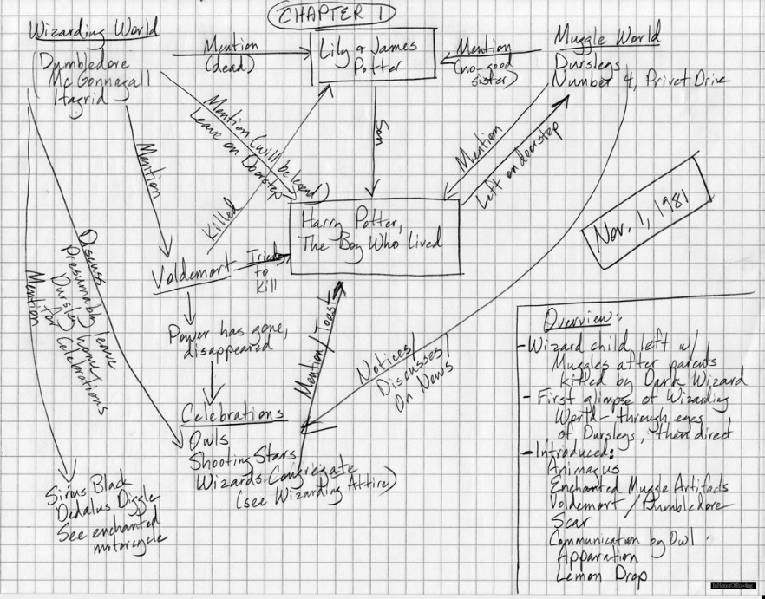
Week 1:

A handwritten plan by J.K. Rowling for the start of the Harry Potter novels.

A detailed plan is really important when you write. Using the headings below (S.P.I.T.E.), make detailed notes for each of the elements of your story.

Setting:

People:

Ideas (what themes will you try to convey in your writing?):

Tone:

Events:

- Completed

Week 2:
STARTER TASK: Read this extract from the opening of a crime novel. What ‘S.P.I.T.E.’ features can you identify? Why are they effective? Annotate the extract with your ideas.

It was about eleven o’clock in the morning, mid-October, with the sun not shining and a look of hard wet rain in the clearness of the foothills. I was wearing my powder blue suit, with dark blue shirt, tie and display handkerchief, black brogues, black wool socks with dark blue clocks on them. I was neat, clean, shaved and sober, and I didn’t care who knew it. I was everything the well-dressed private detective ought to be. I was calling on four million dollars.

TASK: DRAFT the opening of your story. Make sure that you have a powerful and engaging opening line. You should write at least 100 words.

- Completed

Week 3:
STARTER TASK: Find an exciting new adjective to use in your work. Write the word and its definition below.

WORD:

DEFINITION:

TASK: Edit your story opening USING A DIFFERENT COLOUR PEN. Use these EBIs to help you:

- Check your basic punctuation. Have you used capitals, full stops and commas?
- Now consider where you might punctuate for effect. Can you use punctuation to change the pace or add emphasis? Have you used a range of sentence structure for clarity and effect?
- Challenge your vocabulary. Look at your description – can you make it more powerful and effective?
- Check the FLOW of your work. Read it out loud – does it make sense? Are there ‘clunky’ phrases that you can improve?

- Completed

Week 4:
TASK: WRITE! Continue your story. You should write at least 400 words. Use lined paper if you need more space.

- Completed
Week 5:
STARTER TASK: Draw a picture of your protagonist

TASK: Edit your story USING A DIFFERENT COLOUR PEN. Use these EBIs to help you:

- Check your basic punctuation. Have you used capitals, full stops and commas?
- Now consider where you might punctuate for effect. Can you use punctuation to change the pace or add emphasis? Have you used a range of sentence structure for clarity and effect?
- Challenge your vocabulary. Look at your description – can you make it more powerful and effective?
- Check the FLOW of your work. Read it out loud – does it make sense? Are there ‘clunky’ phrases that you can improve?

- Completed

Week 6:
STARTER TASK: Create a title for your story. Write a paragraph explaining why you have chosen this title. It should be:

- Attention grabbing
- Memorable
- Informative
- Intriguing (your reader should want to find out more!)

The title of my story is: _______________________________________________________

I have chosen this title because

TASK: Write up the final draft of your story on lined paper and give it a catchy title.
- Completed

Extra tasks
- Create a book jacket for your story
- Research love poems and print out one you like. Annotate the poem with language and structure features you can spot. Write a paragraph explaining why you have chosen your poem, and how it is effective.
- Write your own love poem using the ideas from your story. Can you convey the same style and tone in your poem?
- Write a letter to a publisher to persuade them to publish your story. Explain what inspired you to write your story, what sort of tone and style it has, and why you think your story would be appealing to readers. Use persuasive language in your letter.
- Write a blurb for your story. Its purpose is to persuade a reader to buy your book, so make sure you give enough information to interest them, without giving to much away! Use persuasive techniques, such as rhetorical questions and cliffhangers.

Extension / development ideas
- Structure: How does the ‘arc’ of your story influence the reader, or impact the narrative?
- Contrast: Does your story have ‘light and shade’? Contrast can be used to highlight key events or emotions. Can you develop your story with this technique?
- The senses: Using sight, sound, smell etc. can be a powerful way to add atmosphere to your work.

