Media:
Advertising
Homework
Year 8

6 week project

This term, you will be working on a non-fiction writing project for your homework tasks.
At the end of the project you will have invented your own product, produced an advert for the product and evaluated its strengths and weaknesses.

You will be aiming to develop the following skills:

- Researching existing advertising campaigns
- Identifying where brands have used language and presentational features for effect.
- Creating your own product and accompanying persuasive advertising campaign.
- Evaluating the success of your advertising campaign and setting targets for the future.

KEY WORDS
Advertisement: a notice or announcement in a public medium promoting a product.
Language features: to ensure that your writing persuades your audience to buy your product.
Presentational features: To use layout, colour and images to appeal to your target audience
Brand, product, logo, slogan: To ensure that our product has a clear identity.

Type of advert and  product \ shop advertised | What happened in the advert | Why I liked this advert
Advert 1

Product/company:
Advert 2

Product/company:

Advert 3

Product/company:

WEEK 1:
This week, you will look at how companies use TV advertising to appeal to their audiences. You can either watch three adverts live on the TV, or you can find a series of adverts on YouTube to help you fill in the grid below. It will be beneficial for you to be able to pause and re-watch your TV adverts, so using YouTube might be better for this task.

- Completed

WEEK 2:
Below is an example of a print advert for the fizzy drink, Fanta. Look carefully at the advert and fill in the grid that follows, providing definitions and examples of devices. Note- the background of the actual advert is bright orange!

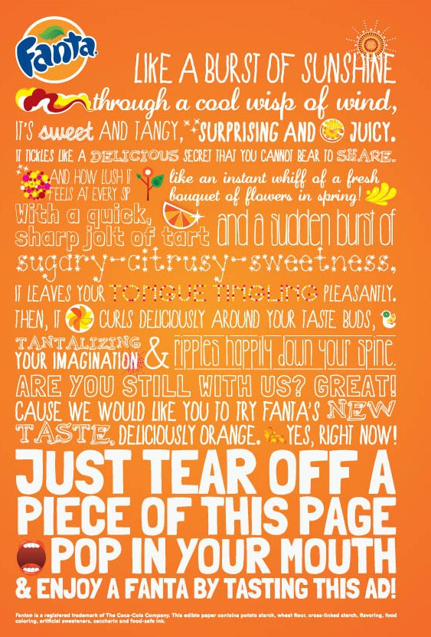

Complete the table below, based on the Fanta advert. The first one has been completed for you. Answer the questions that follow.

Feature | Definition | Example from the advert
Adverb | A word which describes an action (verb) | “pleasantly”
Simile
Adjective(s)
Imagery
Alliteration
Repetition
Rhetorical question
Imperative sentence
Direct address

Which of the features above do you think if the most effective and why?
____________________________________________________________________________________________________________________________________________________________________________________________________________________________________________________________________________________________________________

How are presentational features (the colour, font and images) used for effect?
____________________________________________________________________________________________________________________________________________________________________________________________________________________________________________________________________________________________________________
- Completed
WEEK 3:
Over the following weeks, you will be creating your own advertising campaign for a product you have created. It can be any product you like! This week, you will be designing the product.

Step 1: Think of the category your product will fit into. e.g. Food; clothing; technology. Write the category here:
______________________________________________________________________________________________________________________________________________________

Step 2: Write down what your product is. e.g. a new chocolate bar which you can construct yourself.
_________________________________________________________________________________________________________________________________________________________________________________________________________________________________
___________________________________________________________________________

Step 3: Think about your target audience. Who is your product aimed at? What age? Gender? Lifestyle and interests? Write your ideas in note form:
_______________________________________________________________________________________________________________________________________________________________________________________________________________________________________________________________________________________________________________________________________________________________________________________

Step 4: Give your product a name. Make sure that it’s short, catchy and fits the style of your product. Write it here:
___________________________________________________________________________

Step 5: Write a slogan to go with your product. A slogan is a short, catchy phrase. e.g. Skittles – ‘taste the rainbow’.
______________________________________________________________________________________________________________________________________________________

Step 6: Where will you sell your product? How much will it cost to make? How much will it be sold for? Write down your ideas in note form:
____________________________________________________________________________________________________________________________________________________________________________________________________________________________________________________________________________________________________________
___________________________________________________________________________

On the next page, there is a box for you to sketch your product. Label your product design with features and reasons why you have included them.

Product name:

Logo:

Slogan:

Design: Don’t forget to include labels!

- Completed

WEEK 4:
RESEARCH TASK: Use magazines or the internet to find examples of print adverts for different products. If you google ‘examples of print adverts’, lots will come up. Try to find an example of an advert that fits into the category of your own product.

MAIN TASK: Using what you have researched as inspiration, design and produce a print magazine advert for the product you designed last week. You can both draw and colour it in below, or you can produce it on a computer, print it off and stick it in!

Draw your advert here:

- Completed

WEEK 5:
It’s time to create a storyboard for a TV advert to accompany your product and magazine advert.

In each box, sketch the camera shot and write what is going on underneath.

Here’s an example of a storyboard for an air freshener advert to help you:

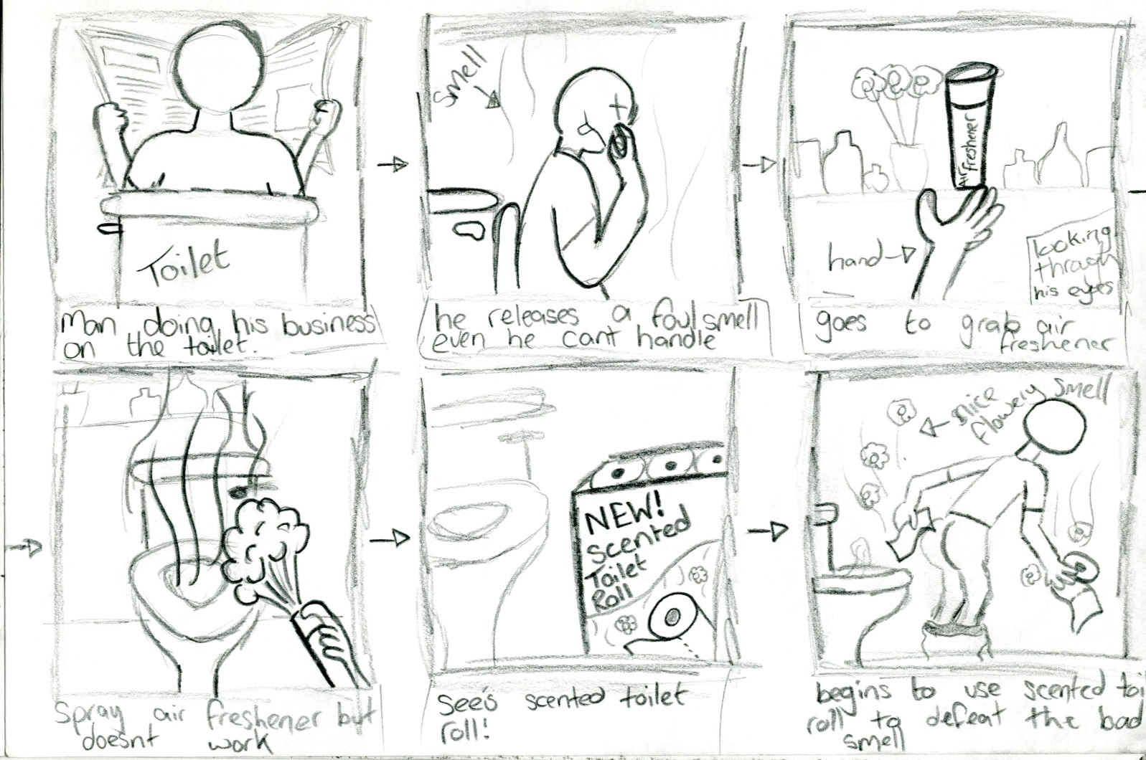

Don’t worry about the quality of your drawing (Stick figures are fine). The focus is on the quality of your ideas.

Use the template on the next page or, if you wish to use more shots, draw it on a separate piece of paper and stick it in.

- Completed

WEEK 6:
In this final week, you are going to EVALUATE your advertising campaign.

Look up the word ‘evaluate’ in the dictionary and write the definition here:
_________________________________________________________________________________________________________________________________________________________________________________________________________________________________

1. Firstly, focus on your print advert from Week 4.

How did you use presentational features to appeal to your target audience? e.g. colour, images, layout.
__________________________________________________________________________________________________________________________________________________________________________________________________________________________________________________________________________________________________________________________________________________________________________________________________________________________________________________________________

How did you use language features to appeal to your target audience? e.g. rhetorical questions, imperatives, direct address. Return to the task you completed in Week 2 to help you.
__________________________________________________________________________________________________________________________________________________________________________________________________________________________________________________________________________________________________________________________________________________________________________________________________________________________________________________________________

Now focus on the storyboard for your TV advert.

2. Why will your TV advert make people want to buy your product? Refer to details from your storyboard.
_____________________________________________________________________________________________________________________________________________________________________________________________________________________________________________________________________________________________________________________________________________________________________________________________________________________________________________________________________________________________________________________________________________

3. Now think about your whole advertising campaign (product design, name, logo, slogan, print advert and TV advert).

Which parts of your campaign do you think are the most effective at appealing to your target audience? Why?
_____________________________________________________________________________________________________________________________________________________________________________________________________________________________________________________________________________________________________________________________________________________________________________________________________________________________________________________________________________________________________________________________________________

Which parts of your campaign do you think are less-effective? Why?
_____________________________________________________________________________________________________________________________________________________________________________________________________________________________________________________________________________________________________________________________________________________________________________________________________________________________________________________________________________________________________________________________________________

What would you do differently if you were asked to complete this project again? Give reasons.
_____________________________________________________________________________________________________________________________________________________________________________________________________________________________________________________________________________________________________________________________________________________________________________________________________________________________________________________________________________________________________________________________________________

- Completed

Extra tasks
- Create a brand for your product. Design an additional product to add to your brand.
- Consider the power of social media. How would you use social media to extend the reach of your product and advertising campaign?
- Ask your English teacher or the school librarian for recommended books about advertising and the media.
Extension / development ideas
- Peer feedback: swap your adverts with a friend and ask them for constructive comments about how to improve.
- Label your print advert and/or TV advert with the features you have used.
- Use a home or school computer to produce your print advert.
- Use a home or school computer to produce your storyboard – some web-based software products can produce them for you.
- Celebrity influence: Which celebrity would you choose to endorse your product and why?

