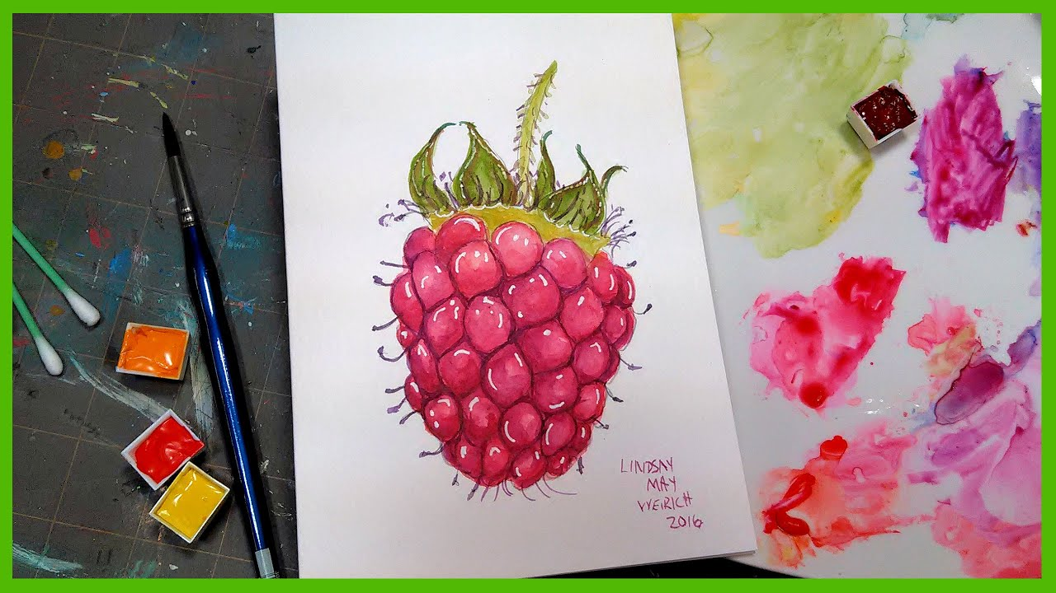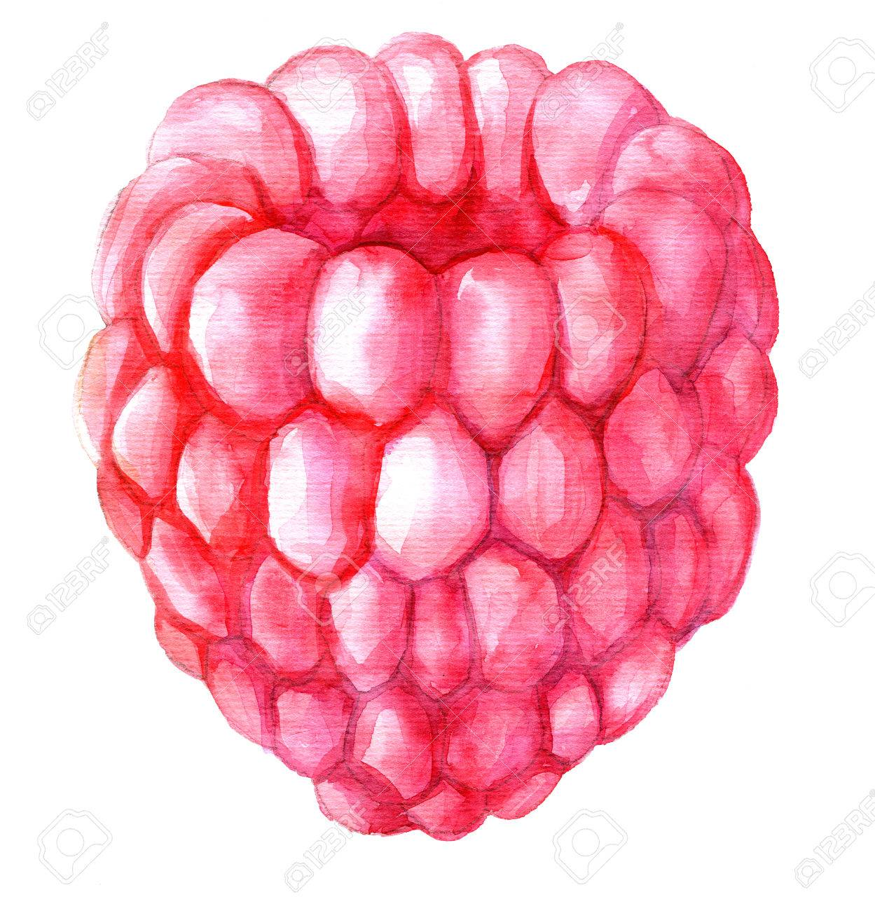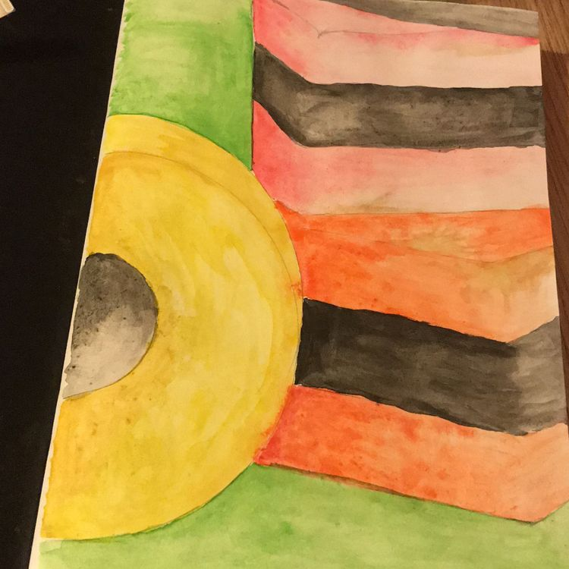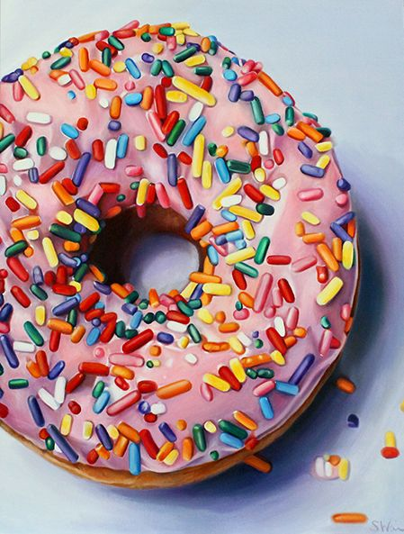

YEAR 8 FOOD ART PROJECT PART 2: DRAWING and PAINTING

Task: Using your photo as reference draw or paint your composition. Remember to zoom in to create an interesting composition and add layers of colour and shading to create depth. If you can’t print your photo then work from the real thing!