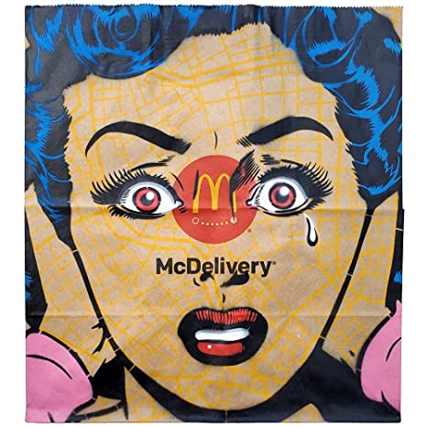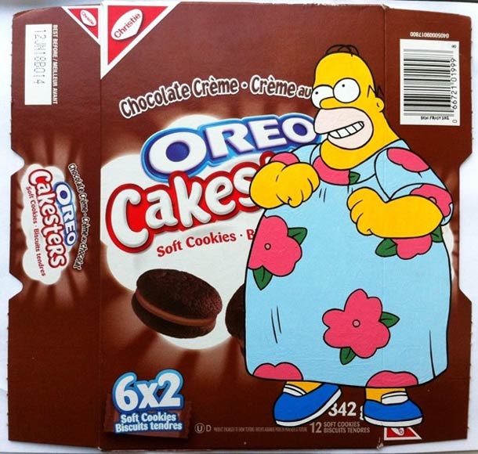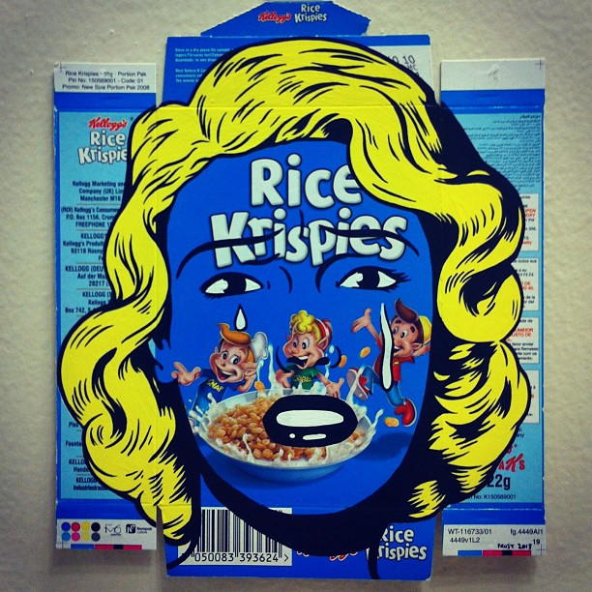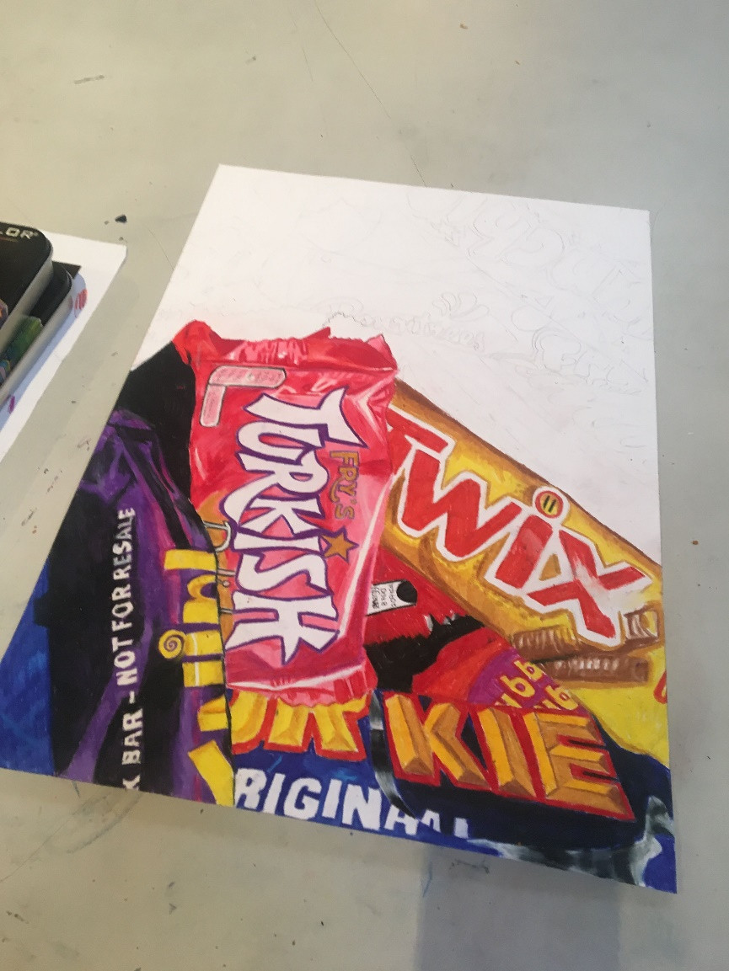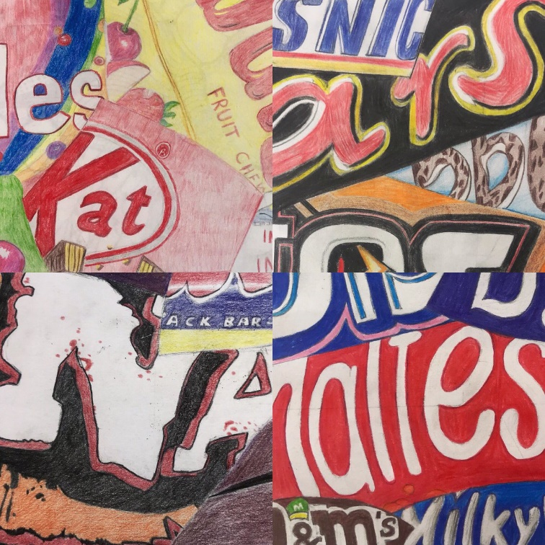

Task 2: Collect some CLEAN packaging and draw or paint on it like the artist Ben Frost.

Task 1: Divide your paper into sections and draw/paint a different section of food packaging into each one. OR draw/paint different packets overlapping each other.

YEAR 8 FOOD ART PROJECT PART 3: PACKAGING