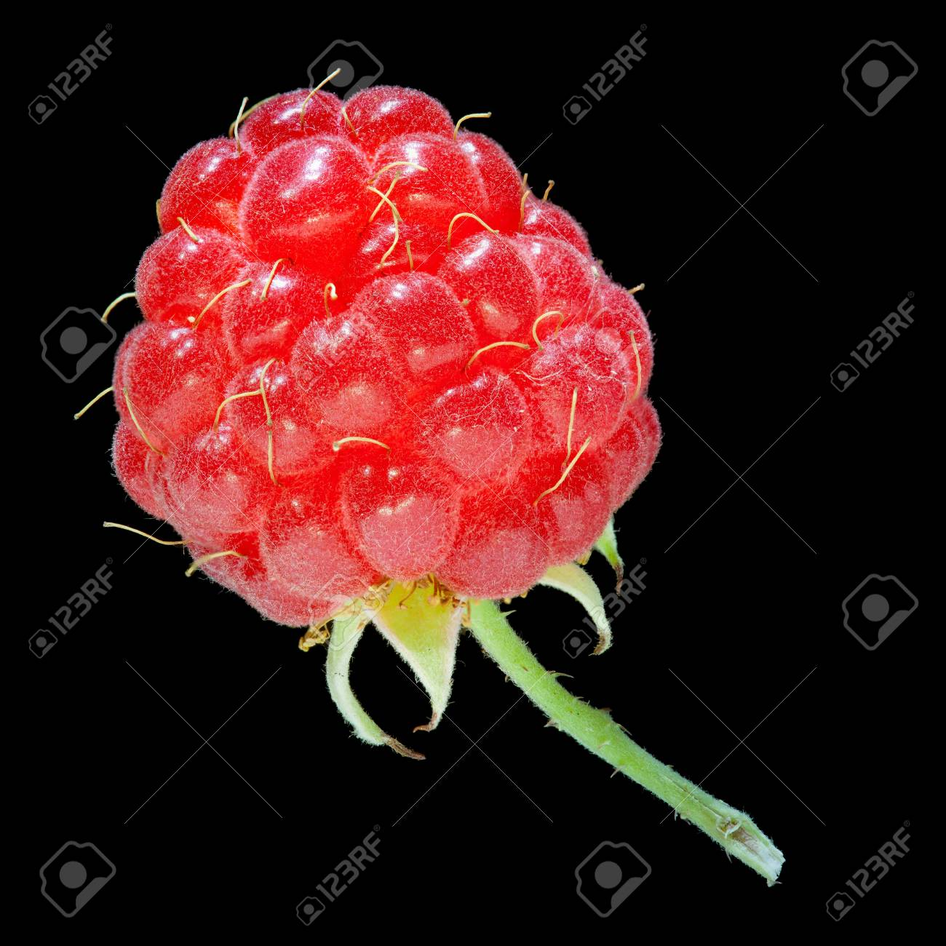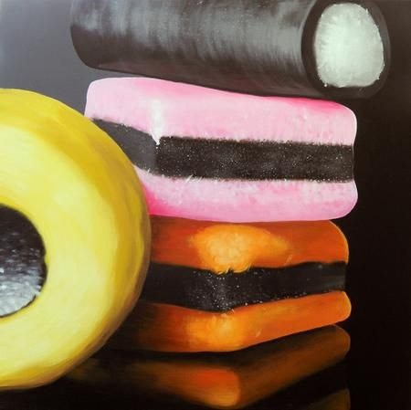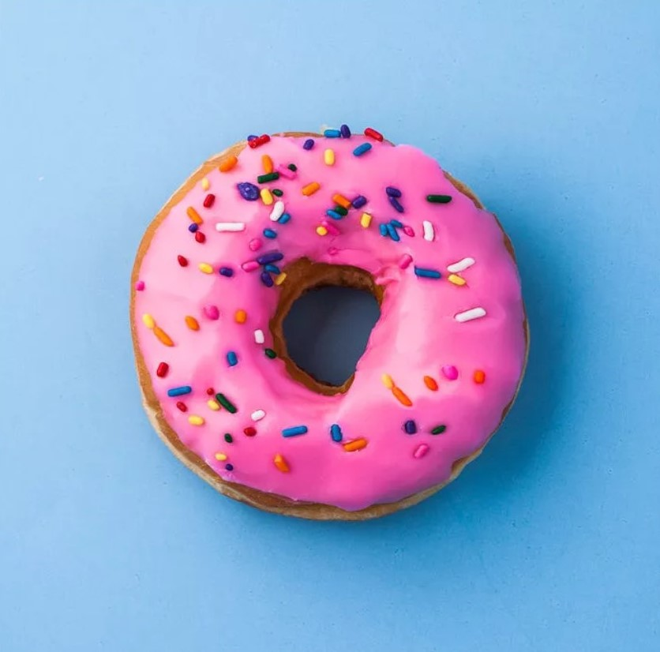

Task 2: Use your smart phone or tablet to photograph close ups of food.

Use available filters to crop and try different effects.

Do as many as you can- it’s fun.

Task 1: Look up the meaning of these terms relating to photography:

FRAME

FOCUS

COMPOSITION

ZOOM

PHOTOSHOOT

YEAR 8 FOOD ART PROJECT: PART 1 PHOTOGRAPHY