Philosophy, religion & ethics work booklet – yr7

Name:

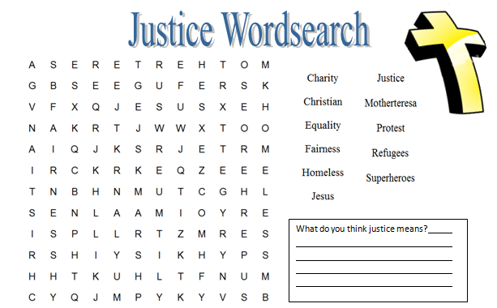
1. What is justice?
- Give three examples of people who can be treated unfairly:

- Describe a time when you feel you have been treated unfairly and how it made you feel:

- Describe two examples from current world issues or in history of unfair treatment:

- Complete the definition of justice:

Justice is when we are for who we are, no what we
like, sound like, or we live. Justice is when we are treated .
where
‘right’
look
treated
matter

5. Read the following story of Cameron’s day:
Fourteen year old Cameron left the house that day for school as normal...well, if you
can call his life normal. His mum was lying in bed probably still drunk. Dad hadn’t come
home last night...again. Who knows where he might be.
Cameron got his two younger brothers out of bed. Sleepily he made them some breakfast. He made sure they had the right clothes for school. He fixed them some sandwiches and a snack for later. He walked them to school.
Halfway there he remembered he’d forgotten his reading book. Cameron made them wait while he ran back to get it. He then made sure the boys went into school. It wouldn’t be the first time they’d run off and missed a day’s classes. Cameron would have to write a note for them. They’d get into big trouble with Dad if he found out.
By the time Cameron got to school he was pretty tired.
History first thing. He had no pencil, he’d just plain forgotten to pack one in his bag this morning. Mr Thomas, the history teacher spoke “Where’s your pencil Cameron?” Cameron could only mumble an apology. Mr Thomas went on, much more loudly...
“NO PENCIL?! WHAT’S THE USE OF COMING TO SCHOOL WITHOUT ONE? DO YOU THINK I HAVE NOTHING BETTER TO DO THAN TO RUN AROUND HANDING OUT PENCILS TO PEOPLE WHO CAN’T BE BOTHERED TO BRING THEIR OWN?...”
Cameron lowered his head.
- Describe one example of Cameron experiencing injustice (unfairness)
in this story:

7. Who do you think is most to blame for Cameron feeling miserable and why?

8. Now choose a character to pretend to be from the story (Mum, Dad, Cameron’s brothers, Mr Thomas, Head teacher, Cameron).
You must explain why you are NOT to blame for Cameron feeling miserable in a few sentences (write in first person, e.g. “I am not blame because…”

9. STRETCH & CHALLENGE: Why do you think injustice (unfair treatment) exists in our society today? What causes it? Where does it come from?

2. WHERE DO WE LOOK FOR God?
a) | Agnostic | Atheist | Theist
What does the word mean?
What reasons might someone give for having this point of view?

b) Would you describe yourself as an agnostic, as an atheist, or as a theist? What reasons would you give?

c) What differences does religious belief make to the way people think and behave? Complete the table below:

 | Religious people | Non-religious people
At work | They might not want to work on holy days.  They might choose a job helping other people, such as nursing. | They might not mind which days they work.
In their spare time | They might get up early to pray.
When they get married |  | They might live together without getting married.
What they might do with their money

How they might bring up their children

d) How much difference do you think religious belief makes to people’s lives? Is it different for different people?

e) What do you believe?
Many religions have statements of belief, which set out the things the members of that religion all agree on. This sort of statement of belief is called a ‘creed’.

Make up your own creed – write seven or eight sentences beginning with the words, ‘I believe…’ and think of the things that are the most important to you. Copy them out onto a piece of paper with a wide border, and use the border to add illustrations –
Here is an example:
I believe that all people are equal and should have equal rights.

I believe that no one should hunt animals for sport.

I believe that the point of living is to be happy and to make other people happy.

I believe that it is what you are like on the inside that really counts, and it doesn’t matter what you look like.

I believe that we should all take care of the environment and not waste things.

I believe that it is important to put your family first.

I believe that after we die, we come back to life again as another person.

Where do we look for God? – part two
Millions of people believe that the universe and our world seem so incredible and wonderful in so many ways that there must be God who designed it – our world is not an accident but made by God.
a) Write down some examples for each of the following in nature:
1) Something in nature that has a beautiful pattern on it.
2) A plant that has special features so that it is suited to a very hot, dry climate.
3) A place in the world that you have been to, or seen on television or in a book, that is spectacularly beautiful.
4) Something in nature that has wonderful colours.
5) Something very clever that the human body can do.
6) An animal that has a very special kind of camouflage.
7) An animal or a bird that can see long distances or hear sounds from far away.
8) An animal that has special features so that it is suited to a very cold climate.

b) What are the things that make you think ‘what a wonderful world’? Give yourself a time limit of five minutes and write down as many as you can until the time is up.

c) Some people think that all the wonderful things in the world show that God must exist – a God who designed and made it all. But other people disagree. What do you think?

