Autobiographical Writing Homework
Year 7
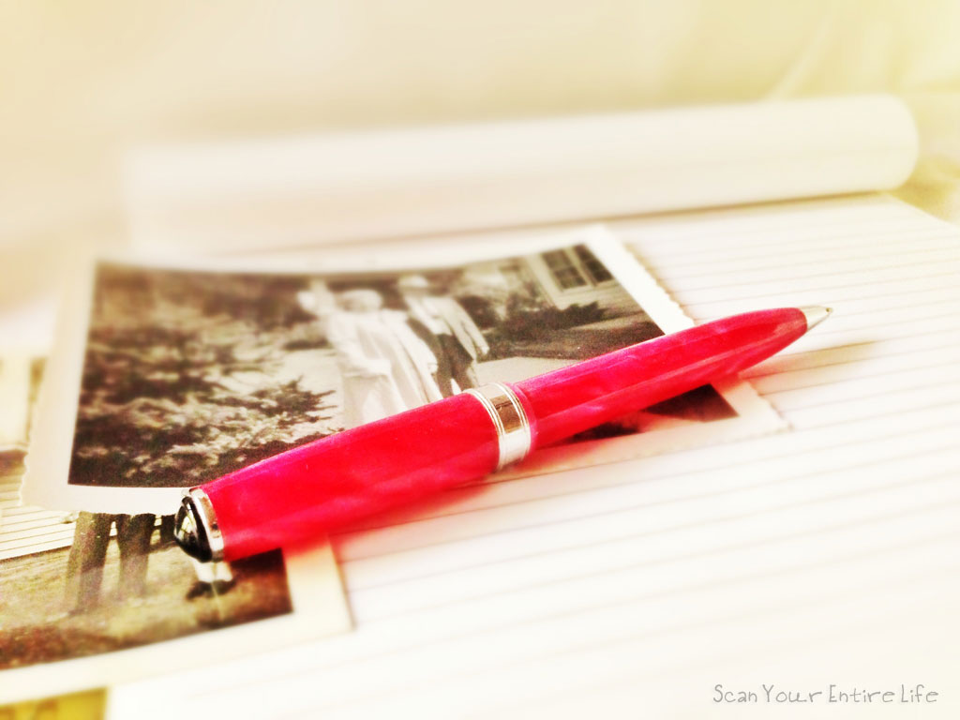
6 week project

This term, you will be working on a creative writing project for your homework tasks.
At the end of the project you will have drafted, edited and completed your own reflection on your first half-term at Heathfield.

You will be aiming to develop the following skills:

- Creating a powerful opening
- Using engaging and ambitious vocabulary
- Punctuating for effect
- Creating effective tone and style
- Drafting and editing

KEY WORDS
First-person narrative: where the narrator tells the story from their own point of view.
Imagery: Descriptive writing that appeals to the senses to create an image in the reader’s mind.
Onomatopoeia: a word that makes a sound (e.g boom)
Adjective: a word that describes a noun (e.g. crusty)
Adverb: a word that describes a verb (e.g lazily)

Week 1:
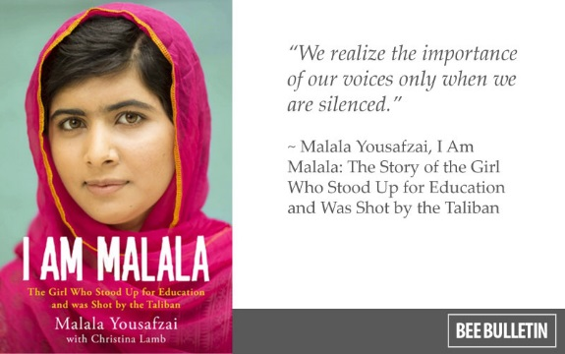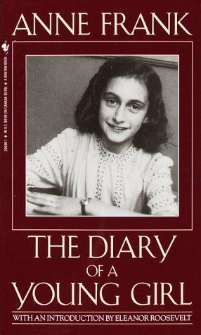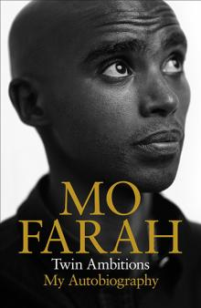

Before we start thinking about how to write an autobiography, we need to understand what it is! Research and answer the following questions in full sentences:

What is an autobiography?

Which language does the word ‘autobiography’ come from? What does it mean when you break it down?

What is the difference between a biography and an autobiography?

What is a first person narrative?

Using the first person, write a paragraph about your earliest memory:

- Completed

Week 2:
Read the following openings from autobiographies and rate them using the table on the following page.
B. From, Trip to Jam Down, by Marcia Chevers
It was arranged that my family would all be going to Jam Down on 19th October 19__. There were five of us who went, my grandmother, my younger brother and sister, mum and myself. I suppose it was quite strange for me because I had never been to Jamaica before, neither had I been abroad.
I had been told a lot about Jamaica, that it was a much nicer and better country than England. I had been told all of these things by my mother and her family who are all living in England. But one of the things that I could never understand was that if it was such a beautiful place then why did they come to England to live and if they felt this way about England then why did they not go back to Jamaica. I knew that question would soon be answered when I went there.
A. From, Small Accidents, by Sabir Bandali
I have always been extremely temperamental – even in my childhood, especially in my childhood. I can remember, vaguely, a few incidents which reflect this. I would flare up and hit anybody my size. I was wild and I was usually avoided and ignored. Perhaps this accounts for the absolutely independent life I now lead. I can remember one incident distinctly.
I was playing with my sister, Mina, who was about five…

C. From, All Men are Brothers, by Tang Hoi Lee
The day I was born, in the Chinese calendar, is the day of the Ghost Festival.
On that day, every year in Hong Kong, people take bits of paper – which is supposed to be money – and burn them. It’s to give the money, when it’s burnt, to the dead, so they can use it in heaven. In the scientific way, it’s unbelievable, but in the old Chinese belief, it’s quite true. So my mum says I come from the other world, because I was born on that day!

D. From, Me and My History, by Anna Leitrim
The thing that sticks in my mind most from when I was very young is the first time I stole something; I was about two years old at the time. My mother and I were visiting friends who had some older children who had practically every toy under the sun because they had rich relatives who spoilt them. All I had was a few cars, a teddy bear and a bedraggled old doll. So I decided that I would have some of their toys. I remember picking out the things that would not be missed and stuffing them behind the pillow in my pram. When it was time to go home, my mum told me to get into the pram, but I refused. So I walked home. When we got home I started taking the toys out. My mum was furious and brought me back with the toys. I had to say sorry, and I remember feeling very resentful because I thought it just was not fair.

Based on your reading of the extracts on the previous page, rate each one using the table below (1= poor – 5= excellent).

 | Extract A | Extract B | Extract C | Extract D
How good is the opening sentence?
How interesting is the topic?
Is the writer using interesting language? (words)
Is the writer using interesting sentence structures?
Do you want to carry on reading?
Total
Write a few sentences about the most-effective extract here. Explain what you liked best about it and why.

- Completed

Week 3:
This week, you will be thinking back to your first impressions of School and using imagery to explore what you experienced.

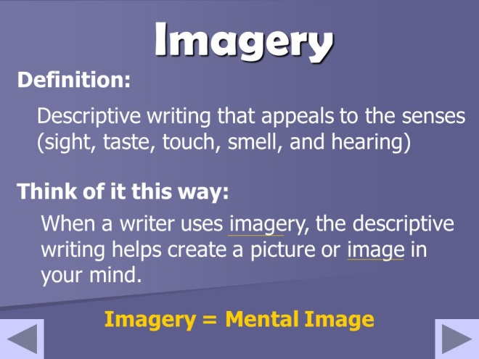

Using the spider-diagram below, list words and phrases which express what you experienced during your first day of secondary school. A couple of examples have been added to help you.
CHALLENGE YOURSELF: Write down phrases rather than words. Use interesting adjectives to describe your experience.
e.g. giant Year 11s

What did you see?

What did you hear?

What did you touch?

My first day at Heathfield

e.g. chemicals and gas in the Science corridor
What did you taste?
What did you smell?

Using the ideas from your spider-diagram, write a description of your first day at School in the space below. It needn’t be very long – we’ll be writing a more extended piece in Week 5. Try to include as many senses as possible in your description.

- Completed

Week 4:

Task 1: Edit your description from last week USING A DIFFERENT COLOUR PEN. Use these EBIs to help you:

- Have you described your experience using the full range of senses?
- Check your basic punctuation. Have you used capitals, full stops and commas?
- Now consider where you might punctuate for effect. Can you use punctuation to change the pace or add emphasis? Have you used a range of sentence structure for clarity and effect?
- Challenge your vocabulary. Look at your description – can you make it more powerful and effective?
- Check the FLOW of your work. Read it out loud – does it make sense? Are there ‘clunky’ phrases that you can improve?

Task 2: Read the extract from Nelson Mandela’s autobiography below. Use two different colours to highlight/underline the following devices:
- Adjectives and adverbs
- Onomatopoeia (words which sound like what they’re describing e.g. ‘boom)
Extract from ‘Long Walk To Freedom’, by Nelson Mandela

Classes commenced the following morning, and along with my fellow students I climbed the steps to the first floor where the classrooms were located. The room itself had a beautifully polished wooden floor. On this first day of classes I was clad in my new boots. I have never worn boots before of any kind, and that first day, I walked like a newly shod horse. I made a terrible racket walking up the steps and almost slipped several times. As I clomped into the classroom, my boots crashing on that shiny wooden floor, I noticed two female students in the first row were watching my lame performance with great amusement. The prettier of the two leaned over to her friend and said loud enough for all to hear: “The country boy is not used to wearing shoes,” at which her friend laughed. I was blind with fury and embarrassment.

Her name was Mathona and she was a bit of a smart aleck. That day I vowed never to talk to her. But as my mortification wore off (and I became more adept at walking with boots) I also got to know her, and she was to become my greatest friend at Clarkebury. She was my first true female friend, a woman I met on equal terms with whom I could confide and share secrets. In many ways, she was the model for all my subsequent friendships with women, for with women I found I could let my hair down and confess to weaknesses and fears I would never reveal to another man.
Copy your favourite sentence from the extract, and explain why you think it’s effective:
____________________________________________________________________________________________________________________________________________________________________________________________________________________________________________________________________________________________________________
___________________________________________________________________________
- Completed
Week 5:
TASK: WRITE! Write a diary entry about your experiences at school so far. It should be entertaining to read, so make sure you use lots of descriptive devices! You should write at least 300 words.

Dear Diary,

- Completed

Week 6:

STARTER: Edit your diary entry from last week USING A DIFFERENT COLOUR PEN. Use these EBIs to help you:

- Have you described your experience using the full range of senses?
- Check your basic punctuation. Have you used capitals, full stops and commas?
- Now consider where you might punctuate for effect. Can you use punctuation to change the pace or add emphasis? Have you used a range of sentence structure for clarity and effect?
- Challenge your vocabulary. Look at your description – can you make it more powerful and effective?
- Check the FLOW of your work. Read it out loud – does it make sense? Are there ‘clunky’ phrases that you can improve?

TASK: Write up the final draft of your diary entry on lined paper and give it a catchy title.

- Completed
Extra tasks
- Create a front cover for your autobiography.
- Visit the school library and browse the autobiographies. Take one out and read it!
- Try your hand at writing a chapter of a biography. Perhaps you could write the biography of a friend.
- Transform your first-term at school into a poem. Using the spider-diagram, write a poem exploring your early experiences at secondary school.
- Write the blurb for your autobiography. Its purpose is to persuade a reader to buy your book, so make sure you give enough information to interest them, without giving too much away!

Extension / development ideas
- Structure: Does your diary entry have an engaging ‘hook’ and conclusion? First impressions are formed at the very beginning of texts, so make sure the beginning catches the reader’s attention.
- Devices: As well as imagery, can you showcase a range of descriptive devices in your writing? Simile; metaphor; personification; onomatopoeia; and alliteration can all make your writing more-engaging to read.
- Sentence structure: Have you varied your sentence structure and sentence lengths? Short sentences can be used for impact and effect.

