Nottingham Behaviour Support Team

Contact us by email: ParentsupportBST@nottinghamcity.gov.uk

Helping Our



Emotions

Big Emotions

None of us was born knowing how to control big emotions and both children and adults can take a while to learn how to control them.

The activities in this booklet have been made to help people take control of the times when those big emotions happen, give you the skills to stay calm and the strategies to help you to respond to disappointments and frustrations with the delightfulness of a sleepy kitten.

Being able to self-regulate is being able to manage feelings so they do not take over our day-to-day lives. This could mean being able to calm down when big feelings start to take over, without becoming too upset or ‘losing it’. However, it is also important to make sure that you do not lock those feelings away but instead think of ways to manage them.

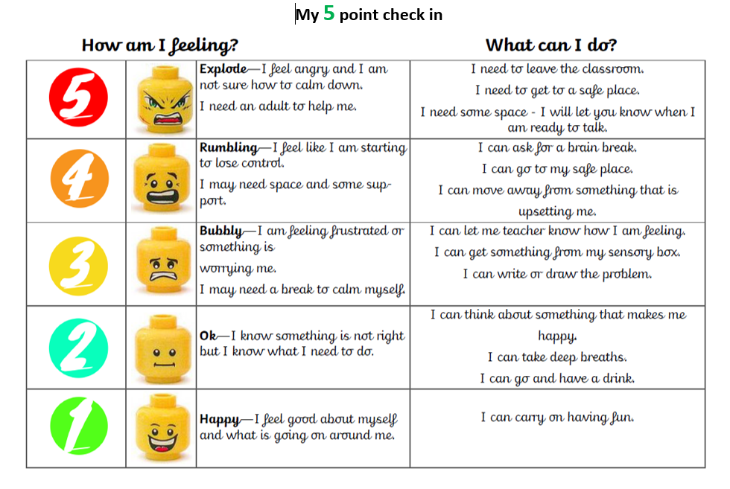

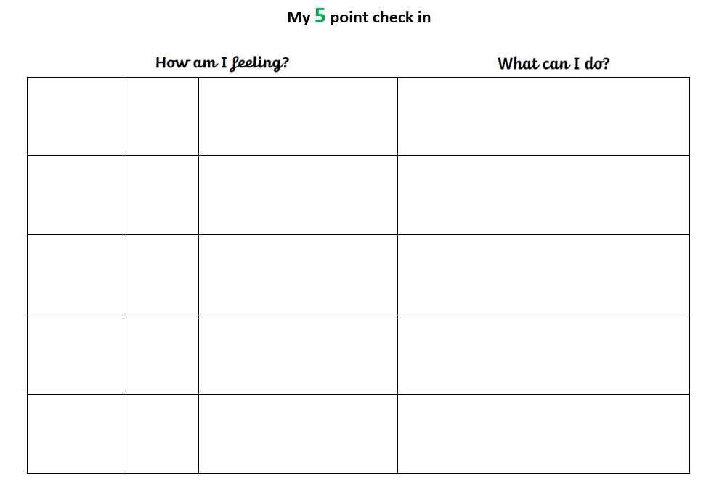

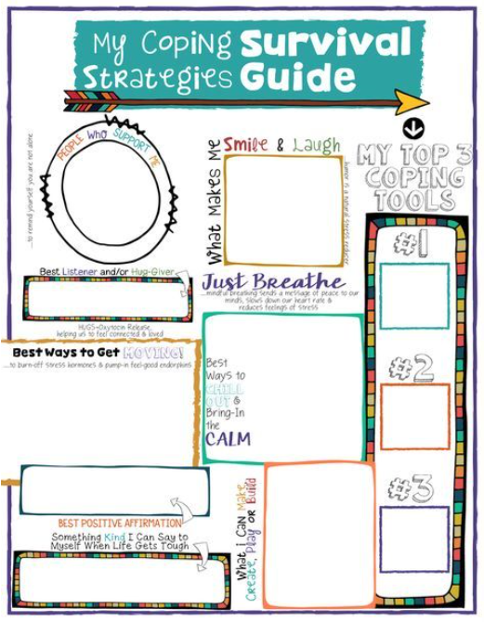

**Milkshake Breathing**

**Equipment – cup, paper straw, water**

Provide your child a plastic cup with a straw so that he/she can practice their milkshake breathing. Fill the cup 1/3rd full with water. Your child breathes in deeply through their nose and breathes out slowly through the straw. Encourage the children to blow SMALL bubbles in the cup very gently – they will know they have it right if they make gentle bubbles without spilling any water.

Have your child practice at least five times and set them little challenges (e.g. how long they can keep the bubbles going for in a single breath, see if you can keep your bubbles going while you count backwards from 4, etc.). These techniques give your child visual and auditory feedback (seeing and hearing the bubbles), and makes the concept more concrete.

Milkshake Breathing Song – to the tune of ‘Twinkle, Twinkle Little Star’  
Teach your child a song about Milkshake Breathing to help them learn what to do.  
Sing together: “We can fill our lungs with air, like we’ve got balloons in there. Then we breathe out soft and slow, making bubbles as we go. Milkshake breathing is so fun; it’s for me and everyone.”



Sometimes, when those big emotions take over it is helpful to try to stop and think about something completely different – this technique is called ‘grounding’. When your mind is racing, grounding brings you back to the here-and-now and is very helpful in managing overpowering feelings. It is a great way to calm down quickly.

Use these cards to help manage those big emotions.

See

Name 5 things you can see.

Touch

Name 4 things you can touch.

Hear

Name 3 things you can hear.

Smell

Name 2 things you can smell.

Breath

Take 1 deep breath.

**Creating a Positivity Jar**

Creating a jar that can be filled with positive words, comments or affirmations can be used to help us when we are feeling sad or when big emotions happen to help us remember how special we are.

You can use any type of jar or draw your own jar and decorate these. However, you wish to make it personal to you.

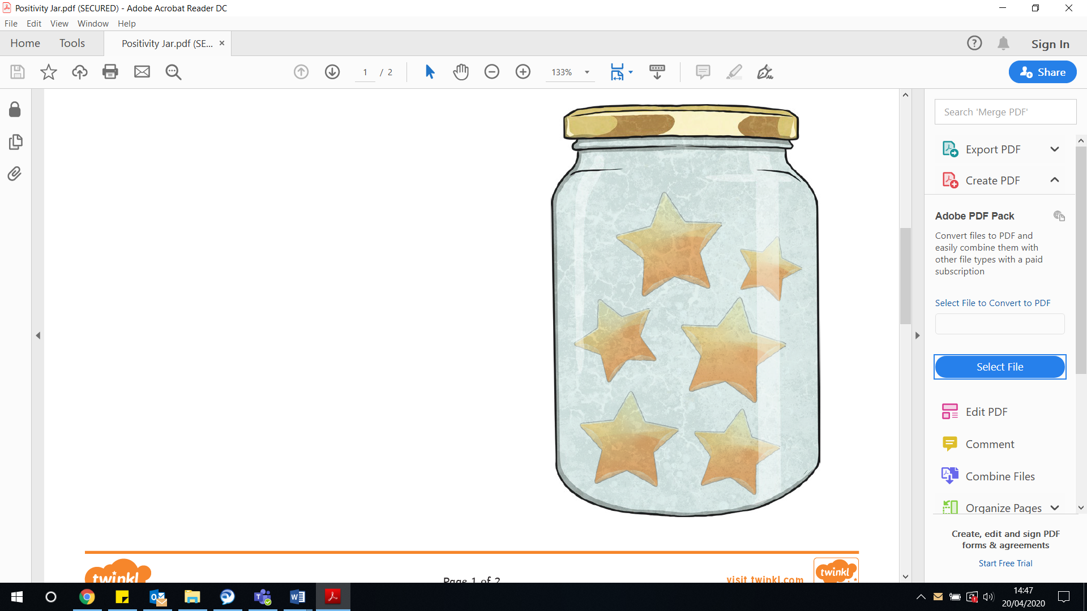

**Things That Make Me Happy**

What makes you happy?

By thinking about the things that make us happy, we can remind ourselves of the things we like to do and try to make sure we are doing these regularly.

Things That Make Me Happy

**Our Worries**

Sometimes we can feel overwhelmed by the big emotions that we have. By writing our worries down, we can feel as though we are emptying our brain. It also allows us to feel in control of our emotions and understand them better.

Writing our worries down also means that we have something to focus on and can help us to try to solve them.

**Gratitude**

Research has shown that showing gratitude can have positive effects on our physical and mental health. This can help us feel happier, reduce our anxiety and help us with our big emotions. It is also important to remind ourselves about the things we are grateful for and this can be done on a daily or weekly basis.

**Gratitude Exercises**

* Name three positive things about your day. These can be as simple as the tasty dinner you ate.
* At the end of the day, name three things you were grateful for.
* Write something nice about someone around you and surprise them with it.
* Write a thank you note for someone who has helped you.
* Complete Daily Acts of Kindness
* Go for a walk and notice as many pleasant things around you as possible.

I am grateful for…

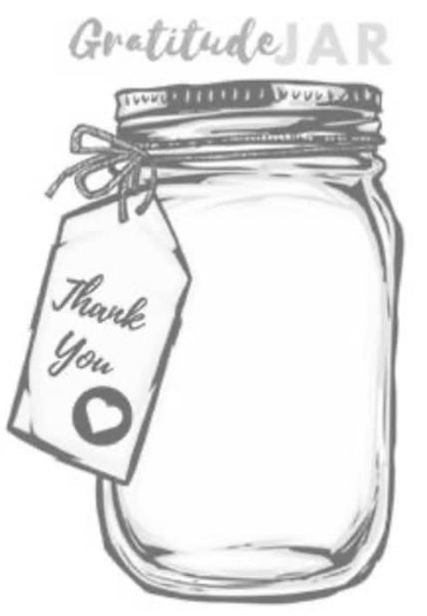

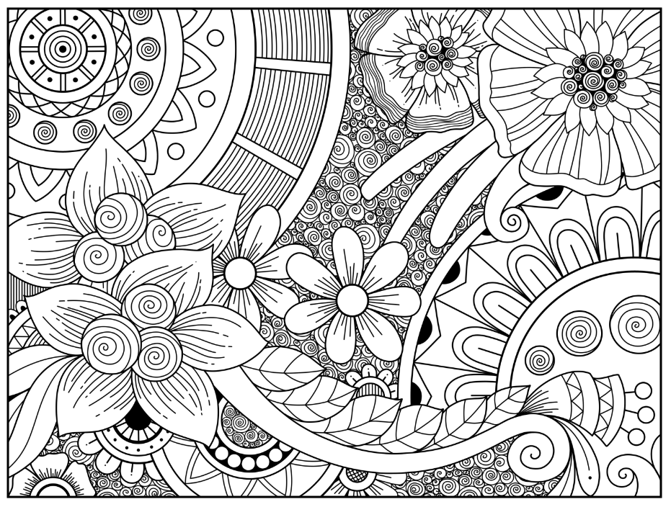

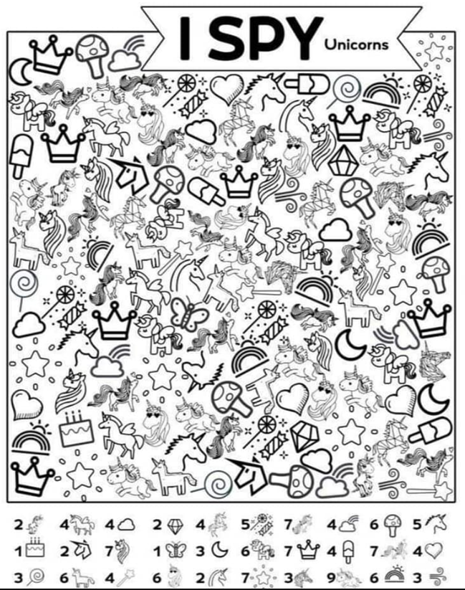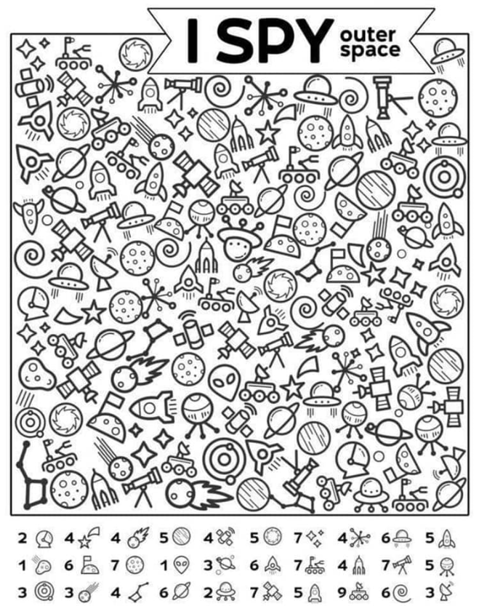

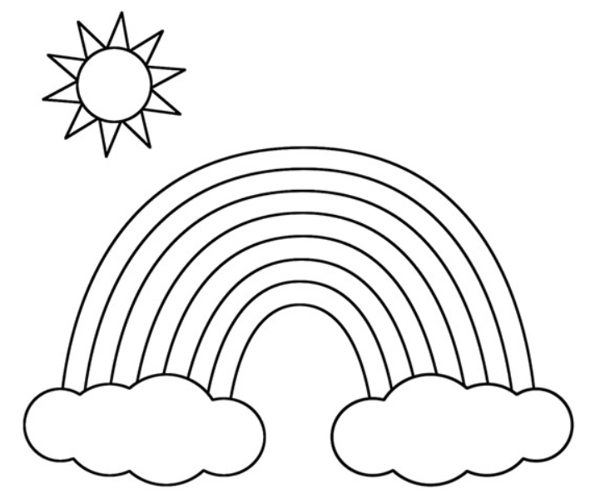

When you go back to school…

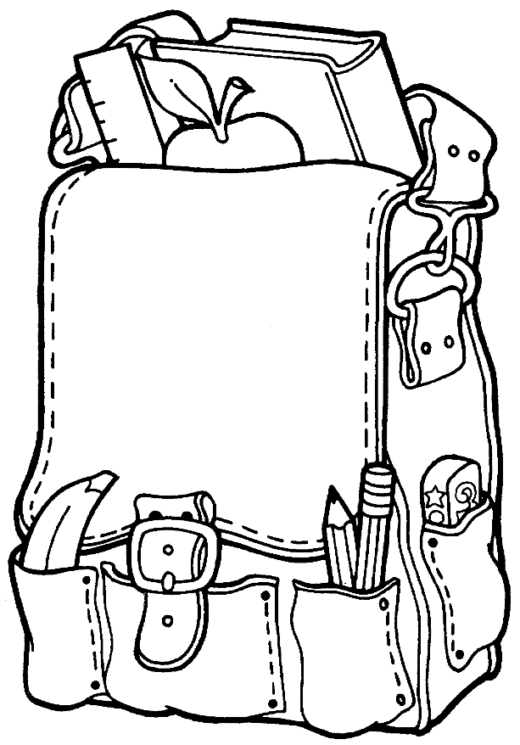

Write down a list of things that you are looking forward to when you go back to school.

